Niyaasoft | DLP Selector Tool (DLPST)

Data protection programme
Data Loss Prevention & Data Security Posture Management - sizing and OEM selection

Customer | Niyyasoft
Recommended OEM | Netskope (96% fit)
Design detailed | Netskope
Prepared by | Niyyasoft
Date | 20 September 2026

OEM facts in this document were collected from official vendor websites only; each is cited with its source URL.

1. Executive summary
5 OEMs were scored against 27 requirements derived from the environment and the priorities set for Niyyasoft. Netskope ranks first with a weighted fit of 96%, meeting 15 of 15 must-have requirements with no gaps. SaaS - Netskope One on NewEdge. Customer-side footprint is 5 VM(s) (2x Netskope Cloud Exchange (Large), 2x Netskope DSPM sidecar (in customer cloud), 1x Netskope DSPM appliance (VMware OVA)); everything else runs in the Netskope tenant.
Rank | OEM | Fit | Reading | Must-haves met | Must-have gaps | Delivery model | Servers to host
#1 | Netskope | 96% | Strong fit | 15 / 15 | None | SaaS - Netskope One on NewEdge | 5
#2 | Proofpoint | 94% | Strong fit | 15 / 15 | None | SaaS - Proofpoint Data Security platform | 3
#3 | Forcepoint | 93% | Strong fit | 15 / 15 | None | Hybrid - Forcepoint DLP 10.4 on-premises + Data Security Cloud | 16
#4 | Symantec (Broadcom) | 92% | Strong fit | 15 / 15 | None | On-premises Enforce + detection servers, with cloud detectors | 8
#5 | Fortra (Digital Guardian) | 92% | Strong fit | 15 / 15 | None | SaaS - Fortra DLP (cloud console + ARC) with on-prem gateways and appliances | 4

2. Requirements

2.1 Environment
Item | Value
Customer | Niyyasoft
Industry / region | Banking & financial services / Saudi Arabia
Programme scope | DLP and DSPM
Deployment preference | No preference
Users | 5,000
Endpoints | 4,500 Windows, 300 macOS, 0 Linux, 0 VDI sessions, 3 site(s)
Email | Microsoft 365, 40 msg/user/day
Web | 1 Gbps egress, no proxy
Cloud apps | Microsoft 365 (OneDrive, SharePoint Online, Teams); inline CASB; GenAI protection
Data at rest | 20 TB file shares, 5 TB SharePoint, 10 databases; full pass in 30 days
DSPM | 5 AWS / 3 Azure / 0 GCP; 200 stores; 100 TB IaaS/PaaS + 50 TB SaaS data
Operations | HA, no DR site, 12 months incident retention
Frameworks | Saudi PDPL (SDAIA), NCA ECC / DCC (Saudi Arabia)
Sizing term | 3 years at 10% annual growth

2.2 Requirements scored
Requirement | Priority | Why it is required
Windows endpoint agent | Must have | 4,500 Windows endpoints
macOS endpoint agent | Must have | 300 macOS endpoints
Cloud email DLP (Microsoft 365 / Google) | Must have | Microsoft 365 email
Web DLP via existing proxy (ICAP) | Nice to have | Alternative web insertion point
Secure Web Gateway from the same vendor | Must have | Web DLP with no ICAP proxy to integrate with
API CASB DLP for sanctioned SaaS | Must have | 1 sanctioned SaaS app(s) in scope
Inline CASB (shadow IT, instance control) | Must have | Shadow IT and instance-level control requested
GenAI app protection (ChatGPT, Copilot, ...) | Must have | GenAI usage control requested
File-share discovery scanning | Must have | 20 TB on file shares
SharePoint / collaboration discovery | Must have | 5 TB in SharePoint
DSPM for AWS | Must have | 5 AWS account(s)
DSPM for Azure | Must have | 3 Azure subscription(s)
DSPM for SaaS data (M365, Google, ...) | Should have | SaaS data stores in posture scope
DSPM for structured data / databases | Should have | Structured data stores in scope
Exact Data Match (EDM) | Must have | Set on the requirements form
Document fingerprinting (IDM) | Must have | Set on the requirements form
OCR / image text detection | Should have | Set on the requirements form
Machine-learning classifiers | Should have | Set on the requirements form
AI / LLM-based classification | Nice to have | Set on the requirements form
User risk scoring / risk-adaptive policy | Should have | Set on the requirements form
Insider-threat activity / screen capture | Nice to have | Set on the requirements form
User-driven classification & labelling | Should have | Set on the requirements form
Microsoft Purview (MIP) label integration | Should have | Set on the requirements form
Encryption / DRM on block or quarantine | Nice to have | Set on the requirements form
Incident workflow & remediation | Must have | Set on the requirements form
SIEM / SOAR integration | Must have | Set on the requirements form
REST API | Should have | Set on the requirements form

3. OEM comparison
Fit by capability area: the weighted share of each area's requirements the OEM documents as available (native = 1.0, add-on product = 0.85, partial = 0.5, not documented = 0.25, not available = 0).
Capability area | Netskope | Proofpoint | Forcepoint | Symantec | Fortra
Endpoint | 85% | 100% | 100% | 100% | 100%
Email, web & network | 100% | 92% | 93% | 93% | 92%
Cloud apps, CASB & GenAI | 100% | 100% | 85% | 90% | 90%
Data-at-rest discovery | 93% | 93% | 100% | 100% | 100%
DSPM | 100% | 85% | 85% | 78% | 88%
Detection & classification | 97% | 100% | 99% | 91% | 86%
Protection & insider risk | 89% | 84% | 85% | 86% | 99%
Operations & integration | 100% | 100% | 100% | 100% | 88%
Overall weighted fit | 96% | 94% | 93% | 92% | 92%

Requirement-by-requirement ratings
Requirement | Priority | Netskope | Proofpoint | Forcepoint | Symantec | Fortra
Windows endpoint agent | Must have | Add-on product | Native | Native | Native | Native
macOS endpoint agent | Must have | Add-on product | Native | Native | Native | Native
Cloud email DLP (Microsoft 365 / Google) | Must have | Native | Native | Native | Native | Native
Web DLP via existing proxy (ICAP) | Nice to have | Native | Add-on product | Native | Native | Add-on product
Secure Web Gateway from the same vendor | Must have | Native | Add-on product | Add-on product | Add-on product | Add-on product
API CASB DLP for sanctioned SaaS | Must have | Native | Native | Add-on product | Add-on product | Add-on product
Inline CASB (shadow IT, instance control) | Must have | Native | Native | Add-on product | Add-on product | Add-on product
GenAI app protection (ChatGPT, Copilot, ...) | Must have | Native | Native | Add-on product | Native | Native
File-share discovery scanning | Must have | Add-on product | Add-on product | Native | Native | Native
SharePoint / collaboration discovery | Must have | Native | Native | Native | Native | Native
DSPM for AWS | Must have | Native | Add-on product | Add-on product | Add-on product | Add-on product
DSPM for Azure | Must have | Native | Add-on product | Add-on product | Add-on product | Add-on product
DSPM for SaaS data (M365, Google, ...) | Should have | Native | Add-on product | Add-on product | Add-on product | Add-on product
DSPM for structured data / databases | Should have | Native | Add-on product | Add-on product | Partial | Native
Exact Data Match (EDM) | Must have | Native | Native | Native | Native | Native
Document fingerprinting (IDM) | Must have | Native | Native | Native | Native | Add-on product
OCR / image text detection | Should have | Native | Native | Native | Add-on product | Add-on product
Machine-learning classifiers | Should have | Native | Native | Native | Native | Add-on product
AI / LLM-based classification | Nice to have | Partial | Native | Add-on product | Not available | Not documented
User risk scoring / risk-adaptive policy | Should have | Add-on product | Native | Add-on product | Native | Native
Insider-threat activity / screen capture | Nice to have | Not documented | Add-on product | Not documented | Not available | Native
User-driven classification & labelling | Should have | Native | Partial | Native | Native | Native
Microsoft Purview (MIP) label integration | Should have | Native | Native | Native | Native | Native
Encryption / DRM on block or quarantine | Nice to have | Native | Add-on product | Partial | Partial | Add-on product
Incident workflow & remediation | Must have | Native | Native | Native | Native | Native
SIEM / SOAR integration | Must have | Native | Native | Native | Native | Native
REST API | Should have | Native | Native | Native | Native | Partial

4. Netskope - fit detail
Netskope One SSE: inline and API DLP, Endpoint DLP, CASB, SWG and DSPM on NewEdge
Weighted fit 96% (Strong fit). Must-have requirements met: 15 of 15.

Strengths for this brief
- Cloud email DLP (Microsoft 365 / Google)
- Secure Web Gateway from the same vendor
- API CASB DLP for sanctioned SaaS
- Inline CASB (shadow IT, instance control)
- GenAI app protection (ChatGPT, Copilot, ...)
- SharePoint / collaboration discovery
- DSPM for AWS
- DSPM for Azure
- DSPM for SaaS data (M365, Google, ...)
- DSPM for structured data / databases

Evidence per requirement
Requirement | Priority | Rating | Evidence (official source)
Windows endpoint agent | Must have | Add-on product | Endpoint DLP is an optional add-on to the Netskope Client; Windows 10/11 x64 (not Win11 Enterprise Multi-Session).  https://docs.netskope.com/en/endpoint-data-loss-prevention
macOS endpoint agent | Must have | Add-on product | Endpoint DLP add-on on macOS 14/15/26, Intel or Apple Silicon, needs Full Disk Access.  https://docs.netskope.com/en/endpoint-data-loss-prevention
Cloud email DLP (Microsoft 365 / Google) | Must have | Native | SMTP proxy integrated in Exchange Online outbound flow plus Next Gen API for Outlook.  https://docs.netskope.com/en/netskope-smtp-proxy
Web DLP via existing proxy (ICAP) | Nice to have | Native | Next Gen SWG with inline DLP; client, explicit proxy, proxy chaining, tunnels; all ports.  https://www.netskope.com/wp-content/uploads/2022/10/2025-01-DLP-DS-10-14-2.pdf
Secure Web Gateway from the same vendor | Must have | Native | Netskope One Next Gen SWG on NewEdge.  https://www.netskope.com/wp-content/uploads/2022/10/2025-01-DLP-DS-10-14-2.pdf
API CASB DLP for sanctioned SaaS | Must have | Native | Classic and Next Generation API Data Protection for ~30 SaaS apps.  https://docs.netskope.com/en/apps-supported-in-classic-and-next-generation-api-data-protection/
Inline CASB (shadow IT, instance control) | Must have | Native | Forward and reverse proxy inline CASB with DLP across ~100,000 SaaS apps incl. instance awareness.  https://www.netskope.com/wp-content/uploads/2022/10/2025-01-DLP-DS-10-14-2.pdf
GenAI app protection (ChatGPT, Copilot, ...) | Must have | Native | Visibility/control over 3,300+ GenAI apps, inline DLP on prompts, AI Guardrails, AI Gateway; API protection for ChatGPT Enterprise, Claude Enterprise, Copilot.  https://docs.netskope.com/en/ai-security
File-share discovery scanning | Must have | Add-on product | Via Netskope One DSPM with on-prem appliance/sidecars: CIFS, SMB, NFS, NetApp ONTAP.  https://docs.netskope.com/en/supported-data-stores-for-netskope-dspm/
SharePoint / collaboration discovery | Must have | Native | SharePoint Online via API Data Protection and DSPM for SaaS.  https://docs.netskope.com/en/apps-supported-in-classic-and-next-generation-api-data-protection/
DSPM for AWS | Must have | Native | Netskope One DSPM: S3, RDS, Aurora, DynamoDB, Redshift, Athena, EBS, EFS, FSx.  https://docs.netskope.com/en/supported-data-stores-for-netskope-dspm/
DSPM for Azure | Must have | Native | Blob, Files, Managed Disks, Azure SQL, MySQL/PostgreSQL/SQL Server, Synapse, Databricks.  https://docs.netskope.com/en/supported-data-stores-for-netskope-dspm/
DSPM for SaaS data (M365, Google, ...) | Should have | Native | Box, Google Drive, OneDrive, SharePoint Online, Salesforce.  https://docs.netskope.com/en/supported-data-stores-for-netskope-dspm/
DSPM for structured data / databases | Should have | Native | Snowflake, Databricks, MongoDB, Heroku Postgres, OCI databases, and on-prem Db2/SQL Server/MySQL/Oracle/PostgreSQL.  https://docs.netskope.com/en/supported-data-stores-for-netskope-dspm/
Exact Data Match (EDM) | Must have | Native | EDM with 2B+ records; hashing via UI, VA, REST API or Cloud Exchange.  https://docs.netskope.com/en/select-an-exact-match-file/
Document fingerprinting (IDM) | Must have | Native | Document fingerprinting for exact/partial matches.  https://www.netskope.com/wp-content/uploads/2022/10/2025-01-DLP-DS-10-14-2.pdf
OCR / image text detection | Should have | Native | OCR on images and PDFs, including on endpoint.  https://www.netskope.com/wp-content/uploads/2022/10/2025-01-DLP-DS-10-14-2.pdf
Machine-learning classifiers | Should have | Native | Built-in ML classifiers plus custom trainable classifiers.  https://www.netskope.com/wp-content/uploads/2022/10/2025-01-DLP-DS-10-14-2.pdf
AI / LLM-based classification | Nice to have | Partial | AI Guardrails classify prompts/responses (MITRE ATLAS/OWASP LLM); LLM-based classification of general data content not explicitly documented.  https://docs.netskope.com/en/ai-security
User risk scoring / risk-adaptive policy | Should have | Add-on product | Advanced UEBA with UCI score and UCI-based inline policies requires additional licensing.  https://docs.netskope.com/en/behavior-analytics-user-confidence-index
Insider-threat activity / screen capture | Nice to have | Not documented | No screen/session recording capability found on official pages.  https://docs.netskope.com/en/behavior-analytics-user-confidence-index
User-driven classification & labelling | Should have | Native | API Data Protection can apply/update MPIP labels; DSPM auto-tags sensitive data.  https://docs.netskope.com/en/irm-integration-with-microsoft-information-protect
Microsoft Purview (MIP) label integration | Should have | Native | Reads MPIP labels (inline CASB, API, Endpoint DLP) and writes via API Data Protection.  https://docs.netskope.com/en/irm-integration-with-microsoft-information-protect
Encryption / DRM on block or quarantine | Nice to have | Native | Policy actions include encrypt and IRM protect; DRM label reading on endpoint.  https://www.netskope.com/wp-content/uploads/2022/10/2025-01-DLP-DS-10-14-2.pdf
Incident workflow & remediation | Must have | Native | Incidents pages for DLP incidents, quarantine, legal hold; forensics; remediation actions (quarantine, unshare, legal hold, restrict access).  https://docs.netskope.com/en/about-dlp
SIEM / SOAR integration | Must have | Native | Cloud Exchange Log Shipper (Splunk/syslog, Sentinel, etc.) and Ticket Orchestrator; Log Streaming (separately licensed) to cloud storage/SIEM.  https://docs.netskope.com/en/log-streaming
REST API | Should have | Native | REST API v2 token-based (Netskope-API-Token), 4 calls/s per endpoint; v1 24 req/5 s.  https://docs.netskope.com/en/rest-api-v2-overview-312207

5. Sizing - Netskope
SaaS - Netskope One on NewEdge. SaaS - Netskope One on NewEdge. Customer-side footprint is 5 VM(s) (2x Netskope Cloud Exchange (Large), 2x Netskope DSPM sidecar (in customer cloud), 1x Netskope DSPM appliance (VMware OVA)); everything else runs in the Netskope tenant.

5.1 Workload (end of term)
Step | Value | How
Growth factor | 1.331x | (1 + 10%) ^ 3 years - every count below is the end-of-term figure
Users | 6,656 | 5,000 today x growth
Endpoint agents | 6,390 | 5,990 Windows + 400 macOS + 0 Linux + 0 VDI sessions
Email - messages/day | 266,240 | 6,656 users x 40 messages
Email - busy hour | 39,936 msg/h | 15% of the daily volume in the busiest hour (planning assumption)
Web egress to inspect | 1.3 Gbps | 1 Gbps today across 1 egress point(s) x growth
Data at rest to scan | 33 TB | 20 TB file shares + 5 TB SharePoint today x growth
Required scan rate | 95 GB/h | full pass in 30 days x 12 scanning hours/day = 360 hours
Cloud accounts in DSPM scope | 8 | 5 AWS accounts + 3 Azure subscriptions + 0 GCP projects
Data under posture management | 200 TB | 133 TB IaaS/PaaS + 67 TB SaaS, x growth
Incidents per day | 333 | estimated at 0.05 per user per day for a tuned policy set (planning assumption - replace with a measured figure)
Incident storage | 29 GB | 333/day x 365 days retention x 250 KB average incident (planning assumption)

5.2 OEM sizing steps
Step | Value | How
Management plane | SaaS | Management planes in 9 countries, including Saudi Arabia  https://www.netskope.com/wp-content/uploads/2026/03/2026-03-NewEdge-DS-333-12.pdf
Clients | 6,390 | Windows + macOS + Linux + VDI sessions  https://docs.netskope.com/en/netskope-client-supported-os-and-platform
IPsec tunnels | 2 | Max 2 Gbps per tunnel; redundant tunnels to two POPs  https://docs.netskope.com/en/ipsec
Email DLP | SMTP proxy | Up to 64 MB scanned per message, 120 s timeout  https://docs.netskope.com/en/netskope-smtp-proxy
Cloud Exchange load | 5K events/min | Netskope planning figure of 0.75 events per minute per user  https://docs.netskope.com/en/cloud-exchange-system-requirements
DSPM sidecars | 2 | ~50-100 medium data stores per sidecar per day  https://docs.netskope.com/es/netskope-dspm-architecture

5.3 Bill of materials
Component | Where | Qty | Specification per unit | Sizing basis
Netskope One tenant (NewEdge) - Next Gen SWG + inline DLP, API data protection, inline CASB, GenAI protection, SMTP proxy email DLP, DSPM | OEM cloud | 1 | SaaS - 120+ data centres in 80+ regions; management planes in 9 countries | Single console for every channel; no customer hardware  https://www.netskope.com/wp-content/uploads/2026/03/2026-03-NewEdge-DS-333-12.pdf
Netskope Client - Traffic steering to NewEdge + Endpoint DLP (Windows/macOS) | Users, endpoints & branches | 6,390 | Typical 0-5% CPU, 100-150 MB RAM, ~150 MB disk | One per endpoint and VDI session; Endpoint DLP is an add-on on Windows and macOS  https://docs.netskope.com/en/netskope-client-supported-os-and-platform
IPsec tunnels to NewEdge - Site steering for agentless devices and servers | Perimeter / DMZ | 2 | 2 Gbps tier per tunnel, IKEv2 | 1.3 Gbps per egress point; tunnels to at least 2 POPs per egress point (1 egress point(s)).  https://docs.netskope.com/en/ipsec
Netskope Cloud Exchange (Large) - SIEM log shipping + EDM hashing | Customer data centre | 2 | 16 cores / 32 GB RAM / 120 GB disk | 6,656 users x 0.75 events/min = 5K events/min; EDM module needs the Large profile (16 cores / 32 GB). Second node for HA - confirm HA topology with Netskope.  https://docs.netskope.com/en/cloud-exchange-system-requirements
Netskope DSPM sidecar (in customer cloud) - Agentless scanning of data stores | Customer cloud (IaaS/PaaS) | 2 | 4 vCPU / 16 GB / 100 GB (AWS m5.xlarge) | 267 data stores over 30 days at 50 stores/day per sidecar (low end of 50-100) = 1; at least one per cloud (2). Add one per isolated VPC/VNet.  https://docs.netskope.com/es/netskope-dspm-architecture
Netskope DSPM appliance (VMware OVA) - On-prem file share (CIFS/NFS) and database scanning | Customer data centre | 1 | 8 cores / 32 GB RAM / 100 GB disk | 95 GB/h to scan; Netskope publishes no files/hour figure, so 100 GB/h per appliance is a planning assumption. More than one needs the distributed model (sidecars + one DLP appliance).  https://docs.netskope.com/en/deploy-dspm-sidecars-via-ova-ovf-on-vmware-vsphere/

Customer-hosted footprint: 5 server(s), 48 vCPU, 128 GB RAM, 540 GB disk.

5.4 Licensing lines
Product / module | Metric | Quantity | Note
Netskope One Next Gen SWG | Users | 6,656 | Inline web DLP
Netskope One CASB (inline + API) | Users | 6,656 | 1 sanctioned app(s)
Netskope One DLP (advanced) | Users | 6,656 | EDM, fingerprinting, OCR, ML across channels
Netskope Endpoint DLP (add-on) | Users | 6,656 | Windows and macOS
Advanced UEBA | Users | 6,656 | UCI-based adaptive policies
Netskope One DSPM | Per Netskope quote | Scope: 200 TB | 8 cloud account(s)

Licensing lines reflect what the design implies and are not a quotation.

6. Diagrams

Logical architecture
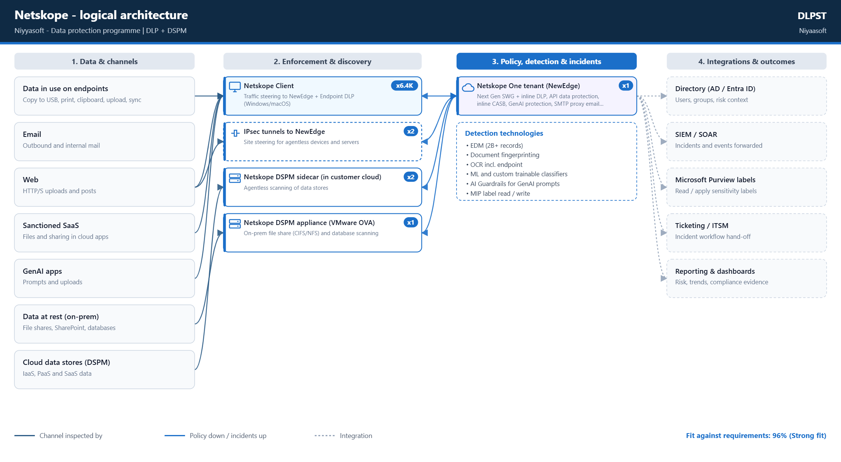
Channels in scope, the component that inspects each one, the policy and incident plane, and the integrations.

Implementation diagram
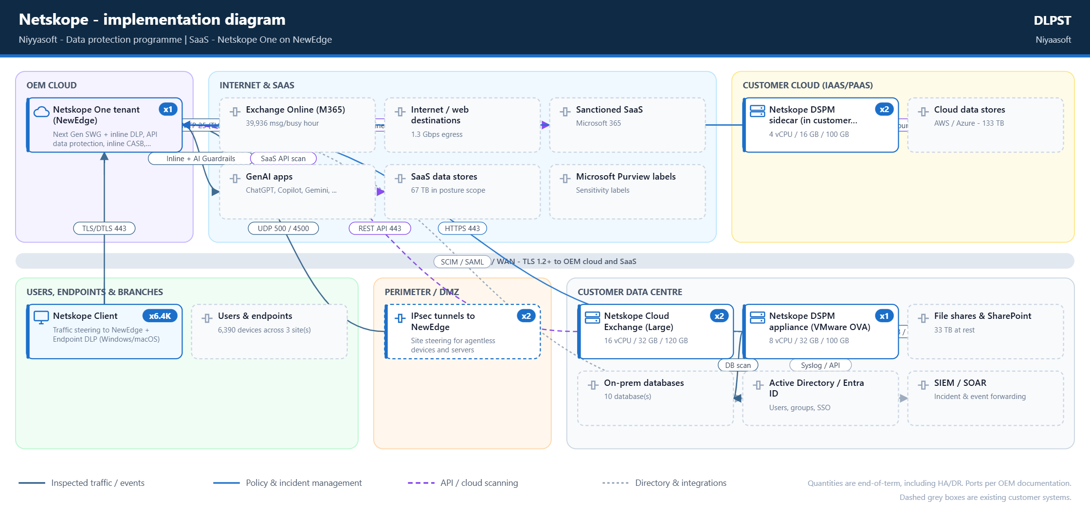
Every component with quantity and specification, placed in its network zone, with the connections and ports the OEM documents.

7. Netskope best practices and rollout plan
- Start DLP policies in Alert mode during initial rollout to understand impact before blocking; then monitor incidents and iterate. [https://community.netskope.com/dlp-7/netskope-dlp-step-by-step-beginner-s-guide-7996]
- Build DLP in order: entities/dictionaries -> rules -> profiles (with file profiles to limit file types and reduce noise) -> policies -> monitor and optimize. [https://community.netskope.com/dlp-7/netskope-dlp-step-by-step-beginner-s-guide-7996]
- Endpoint DLP: begin with permissive device-control baseline plus user-alert (coaching) on sensitive transfers, restrict high-risk groups (e.g. offboarding users read-only), then move to blocking; use forensics to identify false positives. [https://community.netskope.com/inside-netskope-22/endpoint-dlp-netskope-customer-zero-best-practices-615]
- Netskope Client is the recommended steering method for end-user traffic; align steering (cloud apps / web / all traffic) with entitlements. [https://community.netskope.com/real-time-protection-key-policies-72/best-practices-guide-to-maintaining-steering-configuration-7709]
- Keep a test steering configuration to pilot changes on early adopters before production; review default steering exceptions and certificate-pinned app bypasses periodically; change unsanctioned pinned apps from Bypass to Block; log bypassed traffic. [https://community.netskope.com/real-time-protection-key-policies-72/best-practices-guide-to-maintaining-steering-configuration-7709]
- Allow Netskope client destinations through firewalls/proxies without SSL decryption, treat gateway-backup like primary, exclude from full-tunnel VPNs. [https://docs.netskope.com/en/netskope-client-network-configuration]
- Configure IPsec/GRE tunnels to at least two different Netskope POPs; randomize GRE probe timers when multiple tunnels go to same POP. [https://docs.netskope.com/en/gre]
- Deploy at least two NPA publishers per private application and keep a 20% connection-capacity buffer. [https://docs.netskope.com/en/requirements-and-recommendations]
- Do not mix functions on a single Virtual Appliance (e.g. OPLP and DPoP). [https://docs.netskope.com/en/virtual-appliance-overview]
- DSPM: prefer Single Appliance (Standard) deployment for most customers; use Distributed deployment only for large-scale scanning; deploy sidecars in the same network as the DLP appliance; schedule scans/sampling for non-peak times. [https://docs.netskope.com/es/netskope-dspm-architecture]
- In multi-user VDI, give all users on a host the same steering configuration. [https://docs.netskope.com/en/netskope-client-for-virtual-desktop-infrastructure-vdi]
- When enabling larger DLP file sizes, expect higher latency and plan for larger forensic/quarantine/legal-hold storage. [https://docs.netskope.com/en/advanced-file-scanning]

Rollout phases
Phase | Activities
1. Steering foundation | Allowlist client/tunnel destinations; choose steering (Client, IPsec/GRE to 2 POPs, explicit proxy); deploy test steering config to early adopters; review exceptions and cert-pinned apps.
2. DLP content definition | Create entities/dictionaries, rules, DLP profiles and file profiles; import EDM hashes / fingerprints.
3. Monitor (alert-only) | Apply policies in alert mode across web/SaaS/email/endpoint; review incidents and forensics to find false positives.
4. Coach | Enable user-alert/coaching on sensitive transfers (esp. Endpoint DLP) before blocking.
5. Enforce and optimize | Switch tuned policies to block/quarantine; restrict high-risk groups; continuously refine using DLP reports.
DSPM onboarding | Onboard cloud accounts (org-level onboarding auto-detects child accounts/data stores); deploy sidecars (one per VPC/VNet) and DLP appliance/Single Appliance; set scan frequency (hourly to monthly) and sampling.

Policy templates to start from
- Saudi PDPL (SDAIA) - Personal data of Saudi residents (national ID, Iqama, contact, health, financial)
- NCA ECC / DCC (Saudi Arabia) - Data classification and protection controls for national entities

8. Assumptions and caveats
- OEM capabilities, capacities, hardware requirements and ports are taken from the official vendor websites and documentation linked in this document. They change with product releases - confirm against the current documentation before ordering.
- All workload figures are end-of-term values: 10% annual growth compounded over 3 years (factor 1.33).
- Mail busy hour is taken as 15% of daily volume (planning assumption).
- Incident volume is estimated at 0.05 incidents per user per day for a tuned policy set; untuned monitor-mode policies can generate several times more. Replace with a measured figure after the monitoring phase.
- Incident storage assumes 250 KB per stored incident including matched content and metadata (planning assumption).
- Detection servers are sized to run at no more than 75% of the OEM published maximum at the end of the term; HA adds an N+1 unit and a DR site adds a standby set.
- The fit score reflects documented capability, not quality of implementation. "Not documented" means the official documentation reviewed did not show the capability; verify with the OEM.
- Licensing lines reflect what the design implies and are not a quotation. Bundles, editions and terms vary by region and partner.

9. Official sources (Netskope)
- https://www.netskope.com/wp-content/uploads/2026/03/2026-03-NewEdge-DS-333-12.pdf
- https://docs.netskope.com/en/netskope-client-supported-os-and-platform
- https://docs.netskope.com/en/ipsec
- https://docs.netskope.com/en/cloud-exchange-system-requirements
- https://docs.netskope.com/es/netskope-dspm-architecture
- https://docs.netskope.com/en/deploy-dspm-sidecars-via-ova-ovf-on-vmware-vsphere/
- https://docs.netskope.com/en/netskope-smtp-proxy
- https://docs.netskope.com/en/endpoint-data-loss-prevention
- https://www.netskope.com/wp-content/uploads/2022/10/2025-01-DLP-DS-10-14-2.pdf
- https://docs.netskope.com/en/apps-supported-in-classic-and-next-generation-api-data-protection/
- https://docs.netskope.com/en/ai-security
- https://docs.netskope.com/en/supported-data-stores-for-netskope-dspm/
- https://docs.netskope.com/en/select-an-exact-match-file/
- https://docs.netskope.com/en/behavior-analytics-user-confidence-index
- https://docs.netskope.com/en/irm-integration-with-microsoft-information-protect
- https://docs.netskope.com/en/about-dlp
- https://docs.netskope.com/en/log-streaming
- https://docs.netskope.com/en/rest-api-v2-overview-312207
- https://community.netskope.com/dlp-7/netskope-dlp-step-by-step-beginner-s-guide-7996
- https://community.netskope.com/inside-netskope-22/endpoint-dlp-netskope-customer-zero-best-practices-615
- https://community.netskope.com/real-time-protection-key-policies-72/best-practices-guide-to-maintaining-steering-configuration-7709
- https://docs.netskope.com/en/netskope-client-network-configuration
- https://docs.netskope.com/en/gre
- https://docs.netskope.com/en/requirements-and-recommendations
- https://docs.netskope.com/en/virtual-appliance-overview
- https://docs.netskope.com/en/netskope-client-for-virtual-desktop-infrastructure-vdi
- https://docs.netskope.com/en/advanced-file-scanning
Generated by Niyaasoft DLP Selector Tool (DLPST) - generated 2026-09-20 22:13

