NIYYA SOFTWARE

HQ internet edge refresh
Firewall selection and design document
Customer | Niyyasoft
Site | Riyadh HQ
Prepared by | Niyyasoft
Date | 20 September 2026
Recommended platform | 2x Cisco Secure Firewall 3105 (8 Gbps threat protection, 1U Rack)

1. Executive summary
For Niyyasoft at Riyadh HQ we recommend 2 units of the Cisco Secure Firewall 3105, deployed as an active/passive high-availability pair. The design requires 3.7 Gbps of threat-protection throughput once growth and headroom are applied; the Secure Firewall 3105 is rated at 8 Gbps, which puts it at approximately 46% of its capacity on day one. TLS decryption on 40% of traffic has been accounted for separately, as it is the single largest performance cost on any next-generation firewall.

2. Requirements captured
These are the inputs the sizing is based on. If any of them change materially, the model recommendation should be re-run.
Requirement | Value
Deployment role | Campus or HQ internet edge
Protected users | 1,200
User traffic profile | Standard - SaaS, Teams/Zoom voice, file sync
Internet circuit | 2,000 Mbps
Internal traffic to inspect | None
TLS decryption | 40% of traffic
Site-to-site VPN tunnels | 18
Remote-access users | 400
High availability | Active/Passive pair
Growth allowance | 30%
Design headroom | 30%
Required threat throughput | 3.7 Gbps
Required TLS throughput | 1.5 Gbps
Required session table | 228K
Security capabilities | Intrusion prevention (IPS), Web / URL filtering, Sandboxing for unknown files, Remote-access VPN / ZTNA

3. How the size was calculated
Each step below is applied in order. The result is the threat-protection throughput the appliance must sustain - not the raw firewall figure, which is always much higher and is not a safe basis for sizing.
- Internet circuit: 2,000 Mbps = 2 Gbps.
- 1,200 users x 3 Mbps (standard profile) x 0.6 concurrency = 2.2 Gbps.
- Edge role - larger of circuit vs. user demand, plus internal traffic: 2.2 Gbps.
- Plus 30% growth over the contract term: 2.8 Gbps.
- Plus 30% design headroom: 3.7 Gbps of threat-protection throughput required.
- TLS decryption on 40% of traffic: 1.5 Gbps must fit the model TLS inspection figure.
- 18 IPsec site tunnels: 913 Mbps of VPN throughput assumed.
- Session table: ~228K concurrent sessions and ~18K new connections/second.
- Active/passive HA - each node is sized to carry 100% of the load on its own.

4. Recommended platform
Attribute | Specification
Vendor | Cisco
Operating system | Secure Firewall Threat Defense (FTD) / Meraki MX
Model | Secure Firewall 3105
Product family | Secure Firewall 3100
Form factor | 1U Rack
Quantity | 2 units (HA pair)
Firewall throughput | 12 Gbps
Threat protection throughput | 8 Gbps
IPsec VPN throughput | 6 Gbps
TLS inspection throughput | 3 Gbps
Concurrent sessions | 2M
New connections / second | 110K
Onboard interfaces | 8x GE RJ45, 8x 10G SFP+
High availability | Active/Passive
Positioning | Entry 3100 series.

Why this vendor
Snort 3 IPS with Talos intelligence, deep integration with Cisco ISE, Duo, Umbrella and XDR. Meraki MX is the simplest option for distributed retail-style estates.

What to watch
Two very different product lines - FTD and Meraki MX do not share policy or management. Pick one per estate. FMC is an extra appliance or cloud tenant to licence.

Alternative if more headroom is wanted
The Secure Firewall 3110 is the next model up, rated at 17 Gbps of threat protection and 3M concurrent sessions. It is the safer choice if the user count or TLS decryption ratio is likely to rise within the contract term.

5. Licensing and subscriptions
FTD uses Cisco Smart Licensing: an Essentials base licence per device plus term subscriptions for IPS, Malware and URL. Meraki MX is different - an Enterprise or Advanced Security licence per appliance covers everything including support.
Licence / subscription | Type | What it covers | Why it is included
Secure Firewall Essentials (base) | Subscription | Stateful firewall, NAT, routing, application visibility, site-to-site VPN. Mandatory on every FTD device. | Mandatory on every unit.
IPS Subscription (Threat) | Subscription | Snort 3 intrusion prevention with Talos rule updates. | Mandatory on every unit.
Malware Defense | Subscription | File reputation, retrospective detection and Secure Malware Analytics sandboxing. | Covers the requested "Sandboxing for unknown files" requirement.
URL Filtering | Subscription | Talos URL categories and reputation-based web policy. | Covers the requested "Web / URL filtering" requirement.
Cisco Secure Client (Advantage / Premier) | Subscription | Per-user remote-access VPN and posture licensing. Advantage adds posture; Premier adds full ISE integration. | Covers the requested "Remote-access VPN / ZTNA" requirement.
Cisco Solution Support / SNTC | Support | TAC access, software updates and hardware replacement (8x5xNBD up to 24x7x4 on-site). | Mandatory on every unit.
Meraki SD-WAN Plus | Bundle | Meraki only: ThousandEyes integration, smart path selection and application-aware routing. | Covers the requested "SD-WAN across multiple WAN links" requirement.

Quantity: each line item above is required per appliance. With 2 units in this design, multiply the subscription quantities accordingly.

6. Vendor comparison
The same requirements applied across every vendor in scope. The selected option is marked.
Vendor | Model | Form | Threat | TLS | Sessions | Day-one load
Palo Alto Networks | PA-1410 | 1U Rack | 5 Gbps | 2.4 Gbps | 1.1M | 73%
Fortinet | FortiGate 120G | 1U Rack | 5 Gbps | 2.4 Gbps | 2M | 73%
Cisco (selected) | Secure Firewall 3105 | 1U Rack | 8 Gbps | 3 Gbps | 2M | 46%
Sophos | XGS 2100 | 1U Rack | 4.4 Gbps | 2 Gbps | 3.6M | 83%
Forcepoint | NGFW 1105 | 1U Rack | 5.5 Gbps | 2.6 Gbps | 1.6M | 66%

7. Connectivity design
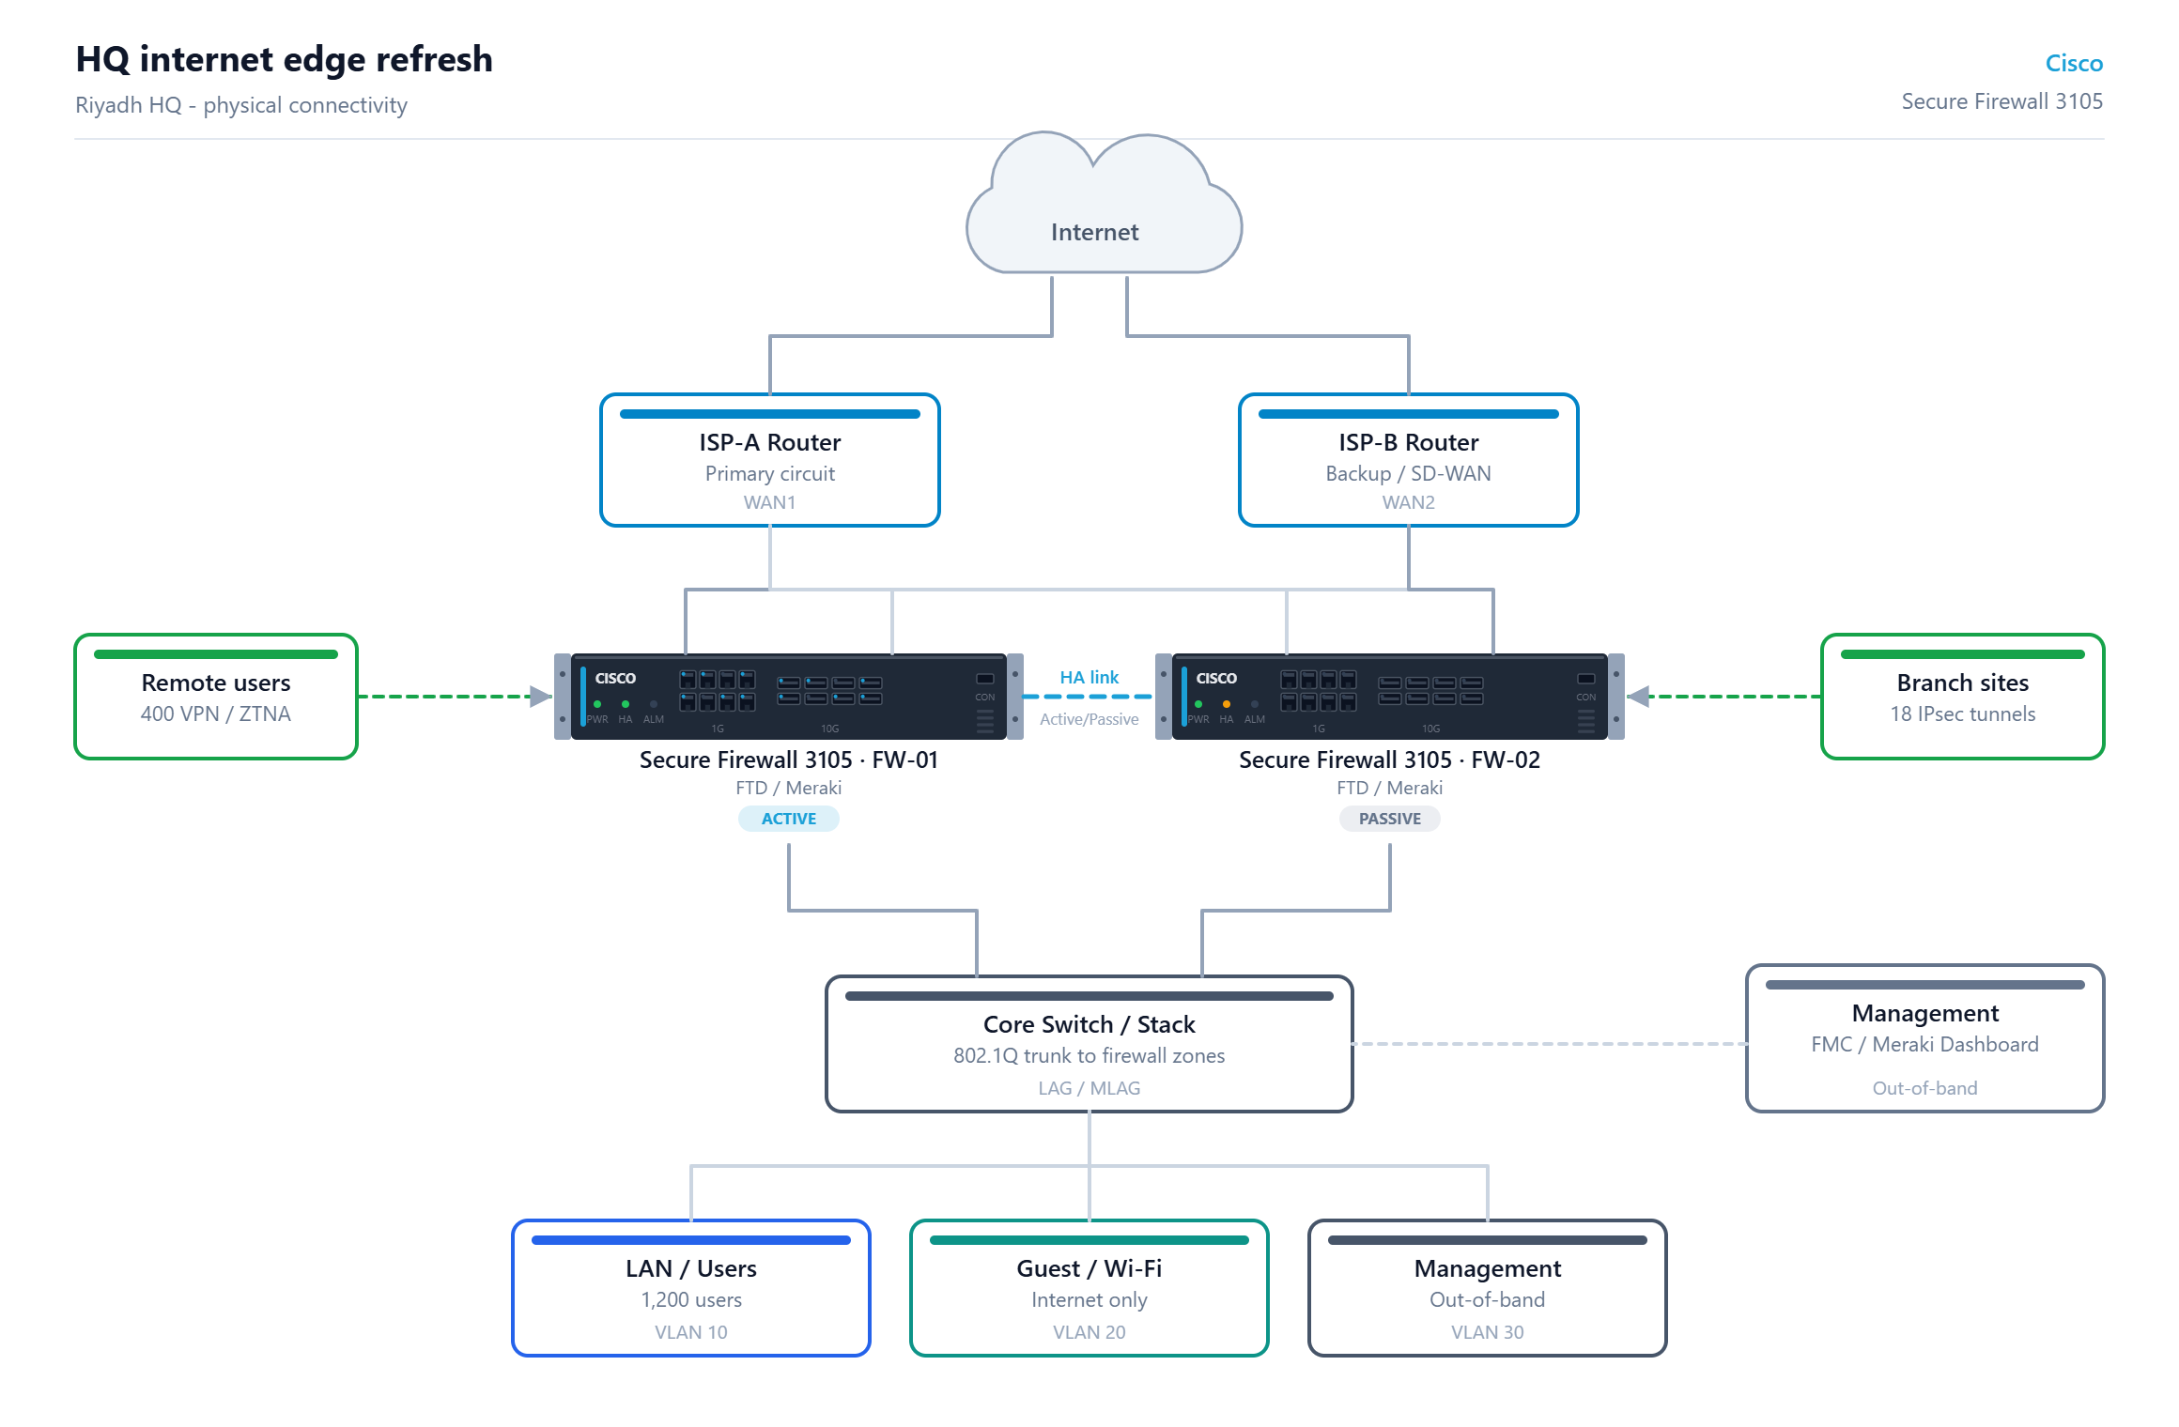
Figure 1 - Physical connectivity from the internet circuit down to the access zones.

Cabling and interface notes
- Onboard interfaces on the Secure Firewall 3105: 8x GE RJ45, 8x 10G SFP+. Confirm optic types (SR/LR) against the switch side before ordering.
- Dedicate two physical links between the HA nodes - one for the control/heartbeat channel and one for session-state sync. Do not share these with data VLANs.
- Cross-connect each firewall to both core switches so a single switch failure does not isolate a node.
- Two independent WAN circuits are shown. Terminate them on separate physical interfaces so the firewall, not the router, makes the failover decision.
- Trunk the firewall-to-core link as 802.1Q and carry one VLAN per security zone; use a LAG or MLAG so the link is not a single point of failure.
- Keep the management interface on an out-of-band VLAN with its own access control - never expose it to the user or internet zones.

8. Zone and policy design
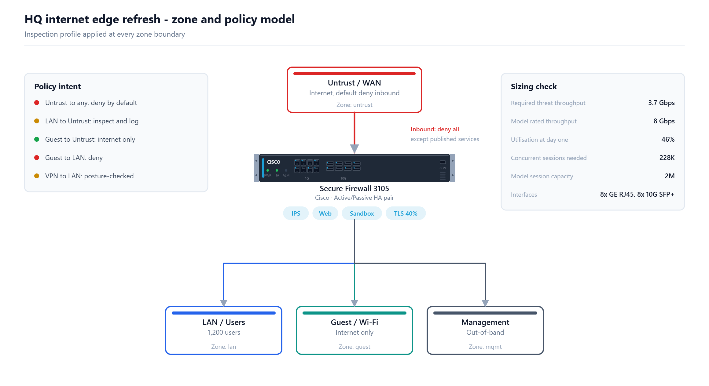
Figure 2 - Security zones and the inspection profile applied at each boundary.
Zone | Purpose | Suggested VLAN
LAN / Users | 1,200 users | 10
Guest / Wi-Fi | Internet only | 20
Management | Out-of-band | 30

Policy intent
Action | Rule intent
Deny | Untrust to any: deny by default
Inspect | LAN to Untrust: inspect and log
Allow | Guest to Untrust: internet only
Deny | Guest to LAN: deny
Inspect | VPN to LAN: posture-checked

9. Assumptions and validation
- Throughput figures are taken from the tool catalogue and are indicative. Confirm the final model against the current vendor datasheet before the order is placed - vendors publish different numbers per test profile and revise them between OS releases.
- Sizing is based on threat-protection throughput with the full inspection stack enabled, not the raw firewall figure.
- A 30% growth allowance and 30% design headroom are included.
- Each node in a high-availability pair is sized to carry the full load on its own, so a single failure does not degrade the service.
- Licence quantities are per appliance. Multi-year terms usually attract a discount and are worth pricing alongside the one-year figure.
- Power, rack space, cooling and structured cabling are assumed to be available at the site and are out of scope for this document.
- Prepared by Niyyasoft on 20 September 2026 using the Niyya Software Firewall Selector Tool.

Generated by the Niyya Firewall Selector Tool - niyyasoft.com - 20 September 2026

