VMware exit - wave 1
V2V - Virtual to Virtual: VMware vSphere / ESXi (vCenter) to Nutanix AHV (Prism)
Niyyasoft | Prepared by Niyyasoft | 20 September 2026

Executive summary
This assessment covers V2V - Virtual to Virtual: VMware vSphere / ESXi (vCenter) to Nutanix AHV (Prism) for 180 workloads. The recommended tool is Commvault Cloud (Complete Backup & Recovery) from Commvault (Paid). Genuine any-to-any conversion on restore across a very wide platform matrix, including UNIX, and strong reporting for audit-heavy programmes. The sections below set out the architecture, the phased plan, the prerequisites and the risks, together with the alternatives considered and why they ranked lower.

At a glance
Item | Detail
Scenario | V2V - Virtual to Virtual: VMware vSphere / ESXi (vCenter) to Nutanix AHV (Prism)
Recommended tool | Commvault Cloud (Complete Backup & Recovery)
OEM / vendor | Commvault
Cost posture | Paid - Per-TB front-end or per-VM subscription
Cutover profile | Warm - seeded online, short cutover window
Workloads in scope | 180
Data to move | 46.0 TB
Link between source and target | 1,000 Mbps
Raw transfer time at 65% efficiency | 6.9 days
Realistic elapsed time | 11 days allowing for delta passes, retries and contention
Waves | 9 waves of about 20

Why this tool
• Supports V2V as a first-class scenario.
• Explicitly supports VMware vSphere / ESXi (vCenter) as a source and Nutanix AHV (Prism) as a target.
• Wave and batch orchestration, which matters at 180 workloads.
• Agentless, so there is no per-server software deployment to get approved.
• Provides changed-block tracking / incremental sync.
• Provides non-disruptive test migration.

Watch out for
• Does not provide live migration (no guest downtime).
• Does not provide rollback / failback after cutover.
• Does not provide application dependency mapping.

Requirements captured
Question | Answer
Project | VMware exit - wave 1
Organisation | Niyyasoft
Migration type | V2V - Virtual to Virtual
Source platform | VMware vSphere / ESXi (vCenter)
Target platform | Nutanix AHV (Prism)
Workloads in scope | 180
Data volume | 46.0 TB
Available bandwidth | 1,000 Mbps
Guest operating systems | Windows, Linux
Downtime tolerance | A planned maintenance window
Budget posture | Cost is secondary to capability
Required capabilities | Changed-block tracking / incremental sync; Live migration (no guest downtime); Non-disruptive test migration; Rollback / failback after cutover; Agentless operation; Discovery and assessment; Application dependency mapping; Programme reporting / audit trail
Regulated / audit evidence needed | No

Recommended tool: Commvault Cloud (Complete Backup & Recovery)
Attribute | Detail
OEM / vendor | Commvault
Cost | Paid - Per-TB front-end or per-VM subscription
Licence model | Subscription by front-end terabyte or per-VM/per-instance, depending on the package.
Cutover profile | Warm - seeded online, short cutover window
Deployment | Both
Designed for | Enterprise estates
Migration types | V2V, P2V, V2C, C2V, C2C
Capabilities | Changed-block tracking / incremental sync; Wave / batch orchestration; Agentless operation; Non-disruptive test migration; Encryption in flight; API / CLI automation; Programme reporting / audit trail; Discovery and assessment
Lifecycle | Current
Reference | https://www.commvault.com/

Strengths
Genuine any-to-any conversion on restore across a very wide platform matrix, including UNIX, and strong reporting for audit-heavy programmes.

Limitations
Complex to set up if you do not already run it; licensing needs careful sizing.

How to license it
Quote through Commvault or a partner; also on AWS/Azure marketplaces for cloud-spend drawdown.

Shortlist and alternatives
Ranked against the constraints you entered. The score is relative within this assessment only - it is a sorting aid, not a product rating.
Tool | OEM / vendor | Cost | Licensing model | Cutover profile | Scale | Fit
Commvault Cloud (Complete Backup & Recovery) | Commvault | Paid | Per-TB front-end or per-VM subscription | Warm - seeded online, short cutover window | Enterprise | 150
Veeam Data Platform (Backup & Replication) | Veeam Software | Paid | Veeam Universal Licence (VUL), typically sold in 10-instance packs | Warm - seeded online, short cutover window | Enterprise | 150
Nutanix Move | Nutanix | Included | No charge to Nutanix customers | Warm - seeded online, short cutover window | Enterprise | 138
NAKIVO Backup & Replication | NAKIVO | Paid | Per-socket or per-workload perpetual/subscription; free trial and a free edition for small use | Warm - seeded online, short cutover window | Mid | 134
Cohesity DataProtect (incl. Veritas NetBackup) | Cohesity | Paid | Per-TB or per-workload subscription | Warm - seeded online, short cutover window | Enterprise | 126
Rubrik Security Cloud | Rubrik | Paid | Per-TB subscription | Warm - seeded online, short cutover window | Enterprise | 122
Storware Backup & Recovery (vProtect) | Storware | Paid | Per-VM or per-socket subscription | Warm - seeded online, short cutover window | Mid | 114
Vinchin Backup & Recovery | Vinchin | Paid | Per-socket / per-host perpetual or subscription; 60-day full-feature trial | Warm - seeded online, short cutover window | Mid | 110
VMware OVF Tool / OVA export-import | Broadcom (VMware) | Free | No licence cost | Cold - full outage for the whole copy | Smb | 22
qemu-img | QEMU project | Open source | No licence cost (GPL) | Cold - full outage for the whole copy | Smb | 14

Supporting tools (discovery, assessment, endpoints)
Use these alongside the migration engine. Discovery and dependency mapping are what make the wave plan real; skipping them is the most common reason migrations slip.
Tool | OEM / vendor | Cost | What it gives you
Device42 (Freshworks) | Freshworks (Device42) | Paid | Agentless discovery with application dependency mapping and move-group generation - the answer to "what talks to what, and what must move together".
Faddom | Faddom | Paid | Fully agentless dependency mapping that stands up in about an hour - good when you cannot get agents approved.
Flexera One (Cloud Migration & Optimization) | Flexera | Paid | Ties discovery to software licence entitlement - critical when moving Oracle, SQL Server or SAP where the target platform changes the licence position.
Google Cloud Migration Center | Google Cloud | Free | Inventory, right-sizing, TCO modelling and group planning before you touch a workload.

High-level migration architecture
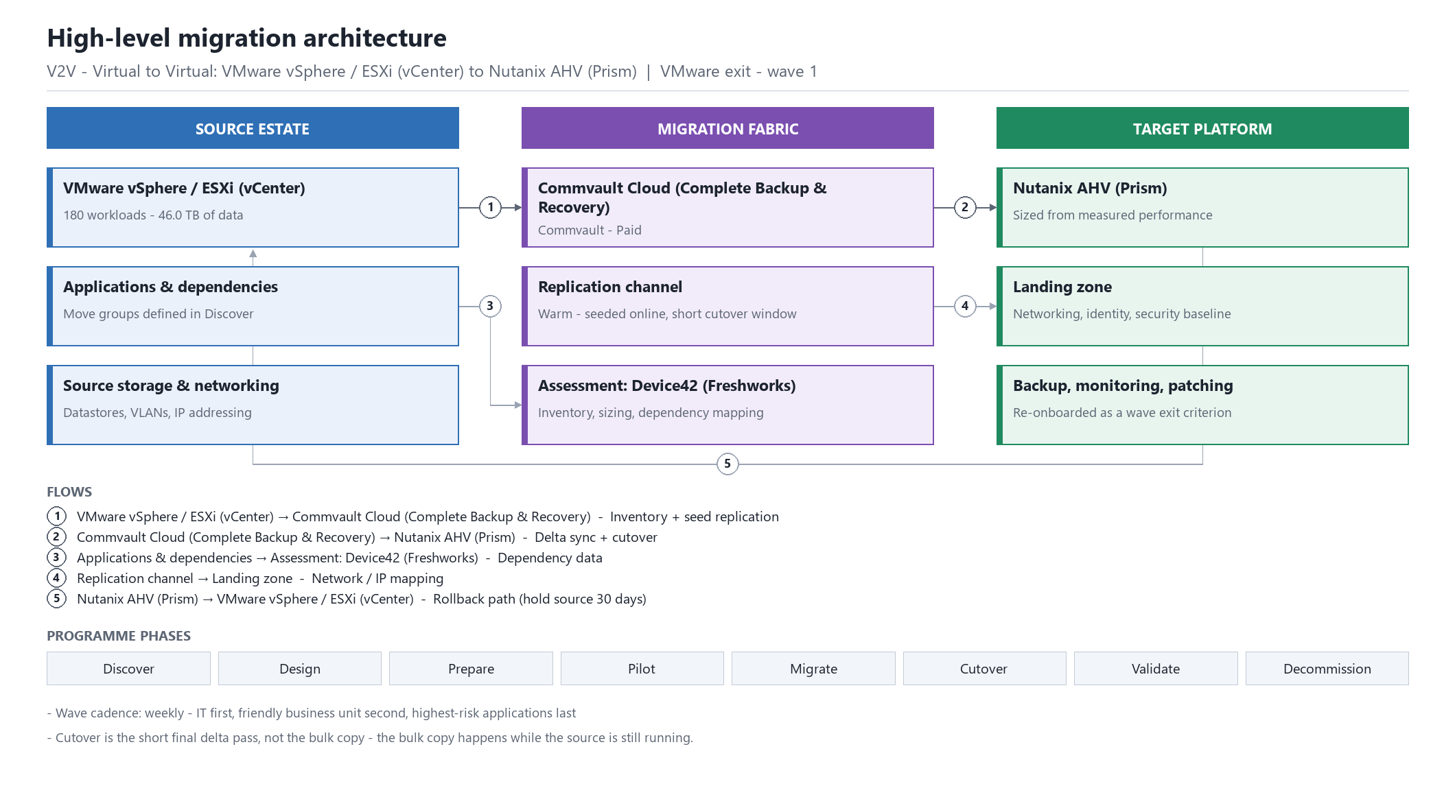
High-level architecture - V2V - Virtual to Virtual: VMware vSphere / ESXi (vCenter) to Nutanix AHV (Prism)

Design notes
• Wave cadence: weekly - IT first, friendly business unit second, highest-risk applications last
• Cutover is the short final delta pass, not the bulk copy - the bulk copy happens while the source is still running.

Low-level migration design
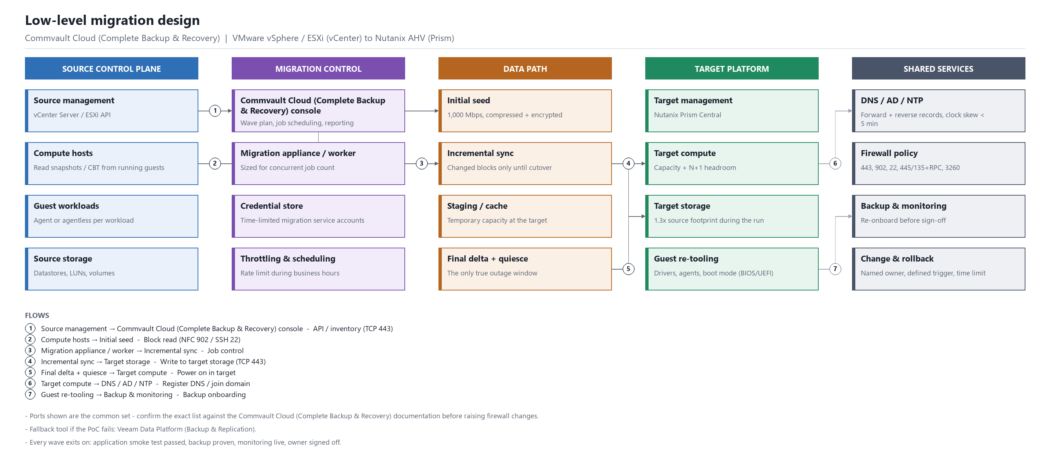
Low-level design - components, data path and controls

Design notes
• Ports shown are the common set - confirm the exact list against the Commvault Cloud (Complete Backup & Recovery) documentation before raising firewall changes.
• Fallback tool if the PoC fails: Veeam Data Platform (Backup & Replication).
• Every wave exits on: application smoke test passed, backup proven, monitoring live, owner signed off.

Migration phases and activities

Discover - Inventory the estate, profile performance, map application dependencies and agree the scope.
• Run an inventory export (RVTools for vSphere, PowerShell for Hyper-V) and reconcile it against the CMDB.
• Profile 7 days of CPU, memory, IOPS and network so the target is sized on real load, not on allocation.
• Map application dependencies and agree the move groups - anything that talks to anything else moves in the same wave.
• Flag workloads that cannot be migrated as-is: licence-locked appliances, USB dongles, physical HBAs, unsupported OS versions.

Design - Size and build the target platform, design networking and storage, pick the tool and prove it in a PoC.
• Size and build the target Nutanix AHV (Prism) capacity including N+1.
• Design IP addressing: keep the same subnets (stretched or re-created) or plan the re-addressing and DNS changes per wave.
• Confirm backup, monitoring, antivirus and patching agents exist for the target platform.
• Prove Commvault Cloud (Complete Backup & Recovery) in a proof of concept against one real workload from each application family.

Prepare - Deploy migration infrastructure, open firewall paths, stage agents, build move groups and waves.
• Deploy the Commvault Cloud (Complete Backup & Recovery) infrastructure and open the required firewall paths.
• Stage guest tools / VirtIO / cloud agents on source VMs ahead of cutover where the tool does not inject them.
• Build the wave plan and book the change windows with each application owner.
• Agree and document the rollback trigger and the decision owner for each wave.

Pilot - Migrate a low-risk wave end to end, measure throughput, validate the runbook and fix what broke.
• Migrate one low-risk, non-production wave end to end.
• Measure actual throughput and extrapolate the real programme duration.
• Run the full validation script and capture how long cutover really takes.
• Update the runbook with what broke - there will be something.

Migrate - Run production waves on the agreed cadence with seeded replication and short cutover windows.
• Seed replication for the next wave while the current wave is being validated.
• Hold a go/no-go 24 hours before each cutover.
• Keep a daily burn-down of migrated versus remaining workloads.
• Re-baseline throughput weekly; bandwidth contention is the usual cause of slippage.

Cutover - Final delta sync, stop the source, repoint DNS/load balancers, power on in the target, smoke test.
• Final delta sync, then quiesce and shut down the source guest.
• Power on in the target, verify IP, DNS, domain membership and time sync.
• Remove source-platform tools and install target-platform tools/drivers.
• Run the application smoke test and get the owner to sign the checklist.

Validate - Application and business sign-off, performance comparison, backup and monitoring re-onboarding.
• Compare performance against the pre-migration baseline and resize where needed.
• Re-onboard to backup and monitoring, and prove one restore.
• Confirm licensing is correct on the new platform - core counts and socket counts change.
• Formal business sign-off per application.

Decommission - Hold the source in a recoverable state for the agreed period, then reclaim licences and hardware.
• Keep the source VM powered off but intact for the agreed hold period (30 days is typical).
• Delete migration agents, appliances and temporary firewall rules.
• Reclaim source licences and update the CMDB and DR documentation.
• Close out the wave in the programme record.

Sizing and wave plan
Measure | Value
Workloads in scope | 180
Data to move | 46.0 TB
Link between source and target | 1,000 Mbps
Raw transfer time at 65% efficiency | 6.9 days
Realistic elapsed time | 11 days allowing for delta passes, retries and contention

Wave plan
Roughly 9 waves of about 20 at a weekly cadence. Wave 1 should be IT only, wave 2 a friendly business unit, and the highest-risk applications last - not first.

Prerequisites and dependencies
Prerequisite | Detail
Management access | Administrative credentials on the source platform (VMware vSphere / ESXi (vCenter)) and the target (Nutanix AHV (Prism)).
Migration network | Routed path from the migration appliance/agents to both platforms, with the replication ports open and no deep packet inspection in the way.
Common ports | TCP 443 (platform APIs and most replication), TCP 902 (ESXi NFC), TCP 22 (Linux/appliance), TCP 445/135 + dynamic RPC (Windows agent push), TCP 1500-1520 (replication varies by product).
Name resolution and time | Forward and reverse DNS for every host involved, and NTP consistency - clock skew breaks certificate and Kerberos-based agents.
Staging capacity | Free capacity on the target for the full wave plus snapshots, typically 1.3x the source footprint during the run.
Guest preparation | Local admin/root on each guest, a current backup taken immediately before cutover, and target platform drivers staged.
Change control | Approved change windows per wave and a named rollback owner.
Licensing for Commvault Cloud (Complete Backup & Recovery) | Quote through Commvault or a partner; also on AWS/Azure marketplaces for cloud-spend drawdown.

Risk register
Risk | Impact | Mitigation
Guest drivers or boot configuration break on the target platform | High | Stage target drivers (VirtIO, Hyper-V IC, cloud agents) before cutover and test one guest per OS family in the pilot.
Software licensing changes on the new platform | High | Review Oracle, SQL Server, SAP and Windows Server licence terms against the target core/socket model before committing - this can dwarf the migration cost.
IP re-addressing breaks hardcoded dependencies | Medium | Prefer L2 extension or identical subnets; where re-addressing is unavoidable, scan configuration files and firewall rules for literal IPs first.
Backup and monitoring coverage lapses after cutover | Medium | Make backup onboarding and a proven restore part of the wave exit criteria.
Discovery is incomplete and workloads appear late | High | Reconcile at least two independent inventory sources and freeze scope with a dated baseline.
Bandwidth is shared with production and throughput collapses | High | Measure real throughput in the pilot, rate-limit replication during business hours, and re-plan waves on actual numbers.
No agreed rollback trigger, so a bad cutover drags on | High | Define the rollback decision point, the owner and the time limit for every wave before it starts.
Application owners are not engaged and sign-off stalls | Medium | Name an accountable owner and a test script per application during Discover, not during Cutover.

Licensing reference
Indicative licensing for planning only. Confirm with the OEM or your reseller before committing - pricing models change, and migration-specific short-term licences are often available but rarely advertised.
Tool | OEM / vendor | Cost | Licence model | How to license it
Commvault Cloud (Complete Backup & Recovery) | Commvault | Paid | Subscription by front-end terabyte or per-VM/per-instance, depending on the package. | Quote through Commvault or a partner; also on AWS/Azure marketplaces for cloud-spend drawdown.
Veeam Data Platform (Backup & Replication) | Veeam Software | Paid | Veeam Universal Licence - portable instances that can be applied to VMs, physical servers, cloud instances or workstations. Per-socket perpetual licences still exist for legacy estates but VUL is the current model. | Buy VUL instance packs (annual subscription, 1/3/5 year) from Veeam or a ProPartner, or via the AWS/Azure marketplace. A licence file is uploaded to the Veeam console. Veeam Community Edition is free for up to 10 instances and can do cross-platform Instant Recovery - enough for a small migration.
Nutanix Move | Nutanix | Included | Free downloadable appliance for any customer with a Nutanix cluster under support. | Sign in to the Nutanix Support Portal with your cluster entitlement and download the Move appliance (OVA/QCOW2). No licence key. Support is covered by your existing AOS contract.
NAKIVO Backup & Replication | NAKIVO | Paid | Perpetual per-socket (hypervisor hosts) or per-workload subscription. NAKIVO also offers a limited free edition. | Buy from NAKIVO or a reseller and apply the licence in the Director web console. Sizing is per CPU socket on the source hosts or per protected workload.
Cohesity DataProtect (incl. Veritas NetBackup) | Cohesity | Paid | Capacity or workload-based subscription. | Quote through Cohesity or a partner.
Rubrik Security Cloud | Rubrik | Paid | Capacity-based subscription. | Quote through Rubrik or a partner.
Device42 (Freshworks) | Freshworks (Device42) | Paid | Annual subscription sized on managed devices. | Quote from Device42/Freshworks or a partner; free trial available.
Faddom | Faddom | Paid | Subscription by number of servers; a free tier covers small environments. | Self-service sign-up with a free tier, then upgrade by server count.
Flexera One (Cloud Migration & Optimization) | Flexera | Paid | Enterprise SaaS subscription. | Quote from Flexera.
Google Cloud Migration Center | Google Cloud | Free | Free Google Cloud service. | Enable the API in your project. No cost.

Assumptions and data currency
• Recommendations are generated from the constraints entered in the wizard on 20 September 2026. Change an answer and the ranking changes.
• Vendor, pricing and licensing data in this report was last reviewed on 2026-09-18. Treat every figure as indicative and confirm with the vendor.
• Throughput and duration figures assume the stated bandwidth is available to the migration and are reduced for protocol overhead, retries and contention. Validate them in the pilot wave.
• This report is a planning aid. It does not replace a proof of concept, a vendor sizing exercise, or a licence-compliance review of the target platform.
Generated by Migration Tool Selector v1.0.0 - Niyya Software, niyyasoft.com. Vendor and licensing data last reviewed 2026-09-18. Confirm all commercial terms with the OEM or your reseller before committing.

