NUTANIX SIZER ULTRA
Cluster Sizing & Design Document
Project | Contoso Datacentre Modernisation
Customer | Contoso Ltd
Prepared by | Solution Architect
Date | 2026-09-20
Version | 1.0
Use cases | Server Virtualisation, VDI / End-User Computing, Databases & Business Critical Apps, Private Cloud / Mixed Workload
Platform | Nutanix NX-8170-G9
Cluster | 22 nodes, N+1, RF2
Licence edition | NCI Pro

Contents

1. Executive summary
The proposed design is a 22-node Nutanix cluster built on Nutanix NX-8170-G9, sized for 834 virtual machines, 3,248 vCPU, 12,487 GB of RAM and 103.1 TiB of workload data.
Each node is configured with 2 x 32-core processors, 1024 GB of memory and 11.52 TB of raw storage, giving a cluster total of 1,408 physical cores, 22,528 GB of memory and 230.5 TiB raw.
The cluster is sized N+1 with Redundancy Factor 2. After replication, failure reserve and the 75% utilisation ceiling, 74.3 TiB of effective capacity is available for workload data.
The binding constraint on node count is cpu: 22 nodes would be required for CPU, 18 for memory and 22 for storage.
NCI Pro is the recommended licence edition, covering all 1,408 physical cores in the cluster for a 36-month term.
Growth is modelled at 12% per year over 3 years; the design point already includes that growth.

Key figures
Metric | Value
Project | Contoso Datacentre Modernisation
Customer | Contoso Ltd
Use cases | Server Virtualisation, VDI / End-User Computing, Databases & Business Critical Apps, Private Cloud / Mixed Workload
Hypervisor | Nutanix AHV
Platform | Nutanix NX-8170-G9
Nodes | 22 (N+1)
Node configuration | 2 x 32 cores, 1024 GB RAM, 11.52 TB raw
Cluster physical cores | 1,408
Cluster memory | 22,528 GB
Cluster raw capacity | 230.5 TiB
Cluster usable capacity | 207.5 TiB
Effective workload capacity | 74.3 TiB
Redundancy Factor | RF2
Rack footprint | 22 chassis, 22 RU
Estimated power | 21.8 kW (74,388 BTU/hr)
Licence edition | NCI Pro
Licence term | 36 months

Design validation findings
Severity | Finding
WARN | Projected storage utilisation is 75% - close to the configured ceiling. Little room for unplanned growth.
INFO | Cluster is 22 nodes, which exceeds the 12-node maximum of NCI Starter. NCI Pro or Ultimate is required.

2. Workload requirements
The table below lists every workload in scope. Growth has already been applied to the totals used for sizing.
Workload | Use case | Source | VMs | vCPU/VM | RAM/VM (GB) | Disk/VM (GB) | Used % | vCPU:core | Total vCPU | Physical cores | Total RAM (GB) | Data (TiB)
Windows general server | Server Virtualisation | Manual | 180 | 4 | 16 | 250 | 62 | 4:1 | 1,012 | 253 | 4,046 | 38.3
Linux general server | Server Virtualisation | Manual | 120 | 2 | 8 | 120 | 55 | 4:1 | 337 | 84 | 1,349 | 10.9
VDI - knowledge workers | VDI / End-User Computing | Manual | 500 | 2 | 6 | 60 | 70 | 6:1 | 1,405 | 234 | 4,215 | 28.8
SQL Server OLTP | Databases & Business Critical Apps | Manual | 10 | 16 | 128 | 2000 | 70 | 2:1 | 225 | 112 | 1,798 | 19.2
Kubernetes workers | Private Cloud / Mixed Workload | Manual | 24 | 8 | 32 | 300 | 60 | 4:1 | 270 | 67 | 1,079 | 5.9
TOTAL |  |  | 834 |  |  |  |  | 4.3:1 | 3,248 | 751 | 12,487 | 103.1
[diagram unavailable]
Figure 1 - Resource demand by workload

3. Cluster design

3.1 Design policy and assumptions
Parameter | Value | Basis
Sizing ratios | Per workload, from its own Nutanix use-case profile | Each workload uses the ratios of its own use case, e.g. VDI at 6:1 next to databases at 2:1. Effective blended ratio across this estate: 4.3 vCPU per physical core.
Redundancy Factor | RF2 | Minimum 3 nodes. Available in every NCI edition.
Failure tolerance | N+1 | Nutanix sizes RF2 clusters N+1 for both compute and storage so a failed node can restart its VMs and re-protect its data.
vCPU : physical core | 4.3 : 1 (blended) | Use-case profile default; validate against measured utilisation.
Memory overcommit | 1 : 1 | AHV does not overcommit memory by default.
CVM allocation | 16 vCPU / 64 GB per node | Nutanix default is 12 vCPU / 32 GB, rising to 16 vCPU / 64 GB for storage-heavy database nodes. All CVM vCPUs must fit inside one socket.
CPU headroom | 25% | Burst and rightsizing allowance held back from the usable core pool.
Memory headroom | 20% | Burst and rightsizing allowance held back from the usable memory pool.
Storage utilisation ceiling | 75% | Nutanix flags Data Resiliency critical when free space drops below the capacity needed to rebuild a node.
Raw to usable overhead | 10% | AOS metadata, oplog, Curator working space and drive formatting.
Compression | On (ratio per use case) | Inline compression is recommended on all containers.
Deduplication | Off | Recommended for VDI and backup data; not recommended for databases.
Erasure Coding (EC-X) | Off | Requires NCI Pro or higher and at least 4 nodes (6+ recommended).
Encryption | On | Software data-at-rest encryption with native KMS is included from NCI Pro 7.3.
Snapshot / clone reserve | Per use case | Capacity held for local snapshots, clones and recovery points.
Growth | 12% per year over 3 years | Applied to all workload demand before sizing.
Thin provisioning | Yes - size on used capacity | Nutanix containers are thin provisioned by default.

3.2 How the node count was derived
Each resource dimension is sized independently and the cluster takes the largest result. In this design the binding constraint is cpu.
Driver | Nodes required | Calculation
CPU | 22 | ceil(1,002 cores required / 48.0 usable cores per node) + 1 spare
Memory | 18 | ceil(15,609 GB required / 952 GB usable per node) + 1 spare
Storage | 22 | ceil(148.4 TiB after RF / (9.4 TiB x 75%)) + 1 spare
Platform minimum | 3 | RF2 minimum cluster size
SELECTED | 22 | Highest of the above (CPU bound)
[diagram unavailable]
Figure 2 - Node count drivers

3.3 Resource balance
Metric | Required | Available | Utilisation
Physical cores | 1,002 | 1,008 | 75%
Memory (GB) | 15,609 | 19,992 | 62%
Usable storage (TiB) | 148.4 | 198.0 | 75%
Estimated IOPS | 150,327 | 3,150,000 | 5%
[diagram unavailable]
Figure 3 - Utilisation against the design ceilings

3.4 Storage capacity model
Capacity is calculated from workload data, through data-efficiency assumptions, the snapshot reserve, the replication factor, the failure reserve and the utilisation ceiling.
Metric | Value
Workload data (post growth) | 103.1 TiB
Provisioned capacity | 160.0 TiB
Combined data efficiency assumed | 1.6 : 1
After data efficiency | 62.8 TiB
Snapshot / clone reserve | 11.4 TiB
Usable capacity required | 74.2 TiB
Capacity after RF2 | 148.4 TiB
Per-node raw | 10.5 TiB (11.52 TB)
Per-node usable after AOS overhead | 9.4 TiB
Cluster raw | 230.5 TiB
Cluster usable | 207.5 TiB
Cluster usable after N+1 | 198.0 TiB
Effective workload capacity at the ceiling | 74.3 TiB
Projected storage utilisation | 75%
[diagram unavailable]
Figure 4 - Raw capacity allocation

4. Hardware platform
Platform data is taken from the official Nutanix Hardware Platform Spec Sheets.
Attribute | Value
Vendor | Nutanix
Model | NX-8170-G9
Published CPU options | Dual Intel Xeon 5th Gen. (Emerald Rapids)
Sockets | 2
Max cores per socket (published) | 32
Max memory per node (published) | 4,096 GB
Storage type | All SSD SED, All NVMe SED, All SSD, NVMe+NST, All NVMe
Form factor | 1U1N (1 node per 1U chassis)
Max raw capacity per node (published) | 184.32 TB
Nutanix published use cases | Database and Business Critical Apps, Analytics and Big Data, End-User Computing/Virtual Desktop Infrastructure, Private Cloud, Server Virtualization, IT Apps, Files and Objects
As configured | 2 x 32 cores, 1024 GB, 11.52 TB raw
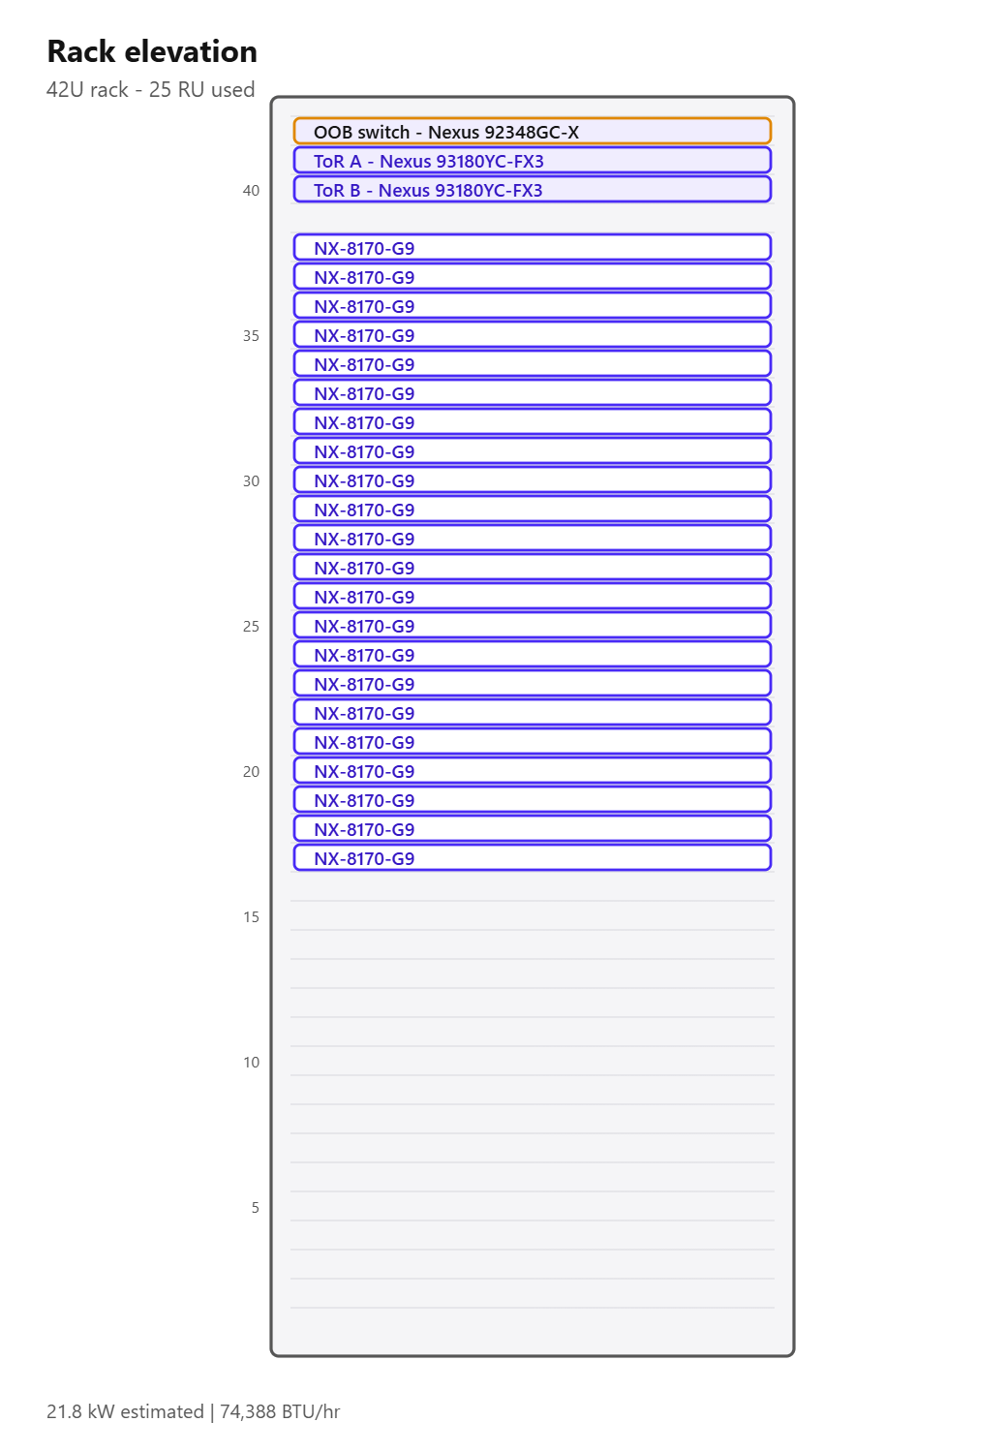
Figure 5 - Rack elevation

5. Network design
Item | Value
Data ToR switch | Cisco Nexus 93180YC-FX3
ToR switch count | 2 (1 redundant pair)
Switch redundancy technology | vPC
Out-of-band switch | Cisco Nexus 92348GC-X x 1
NIC per node | 2 x 25 GbE
Total node data ports | 44
Access port utilisation | 46%
Bond mode | active-backup (Nutanix default)
Switch requirement for bond mode | No MLAG required. Both ToR switches carry the same VLANs.
Uplinks per switch | 2 x 100 G
Northbound bandwidth | 400 Gbps
Node-to-fabric bandwidth | 1,100 Gbps
MTU | 1500
Data cables | 44
Uplink cables | 4
Peer-link cables | 2
Out-of-band cables | 22

5.1 VLAN plan
VLAN | Purpose | Example subnet | MTU | Notes
10 | CVM / AHV Management | 10.10.10.0/24 | 1500 | CVM eth0 and AHV host management. Must be the same L2 for all nodes in a cluster.
20 | Backplane / Storage (optional) | 10.10.20.0/24 | 9000 | Only when network segmentation for the storage backplane is enabled.
100 | VM Guest Networks | 10.10.100.0/22 | 1500 | One or more guest VLANs presented to br0 as AHV networks.
30 | Live Migration (ESXi vMotion) | 10.10.30.0/24 | 9000 | Only for ESXi clusters. AHV live migration uses the management network.
99 | Out-of-band / IPMI | 10.10.99.0/24 | 1500 | IPMI / iDRAC / XCC / CIMC / iRMC. Separate physical switch recommended.
40 | DR / Replication | 10.10.40.0/24 | 1500 | Async / NearSync / Metro replication traffic to the secondary site.

5.2 Physical connectivity
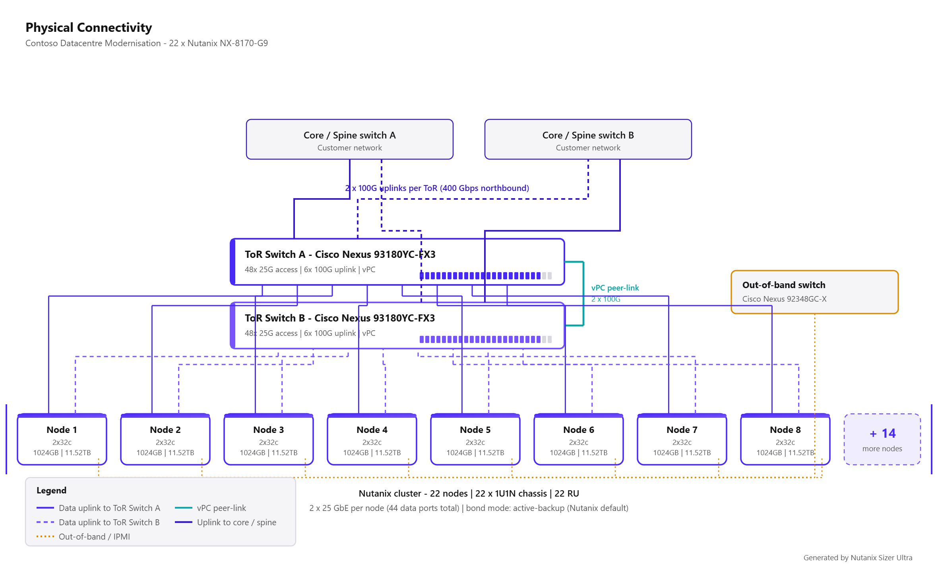
Figure 6 - Physical connectivity diagram

5.3 Logical architecture
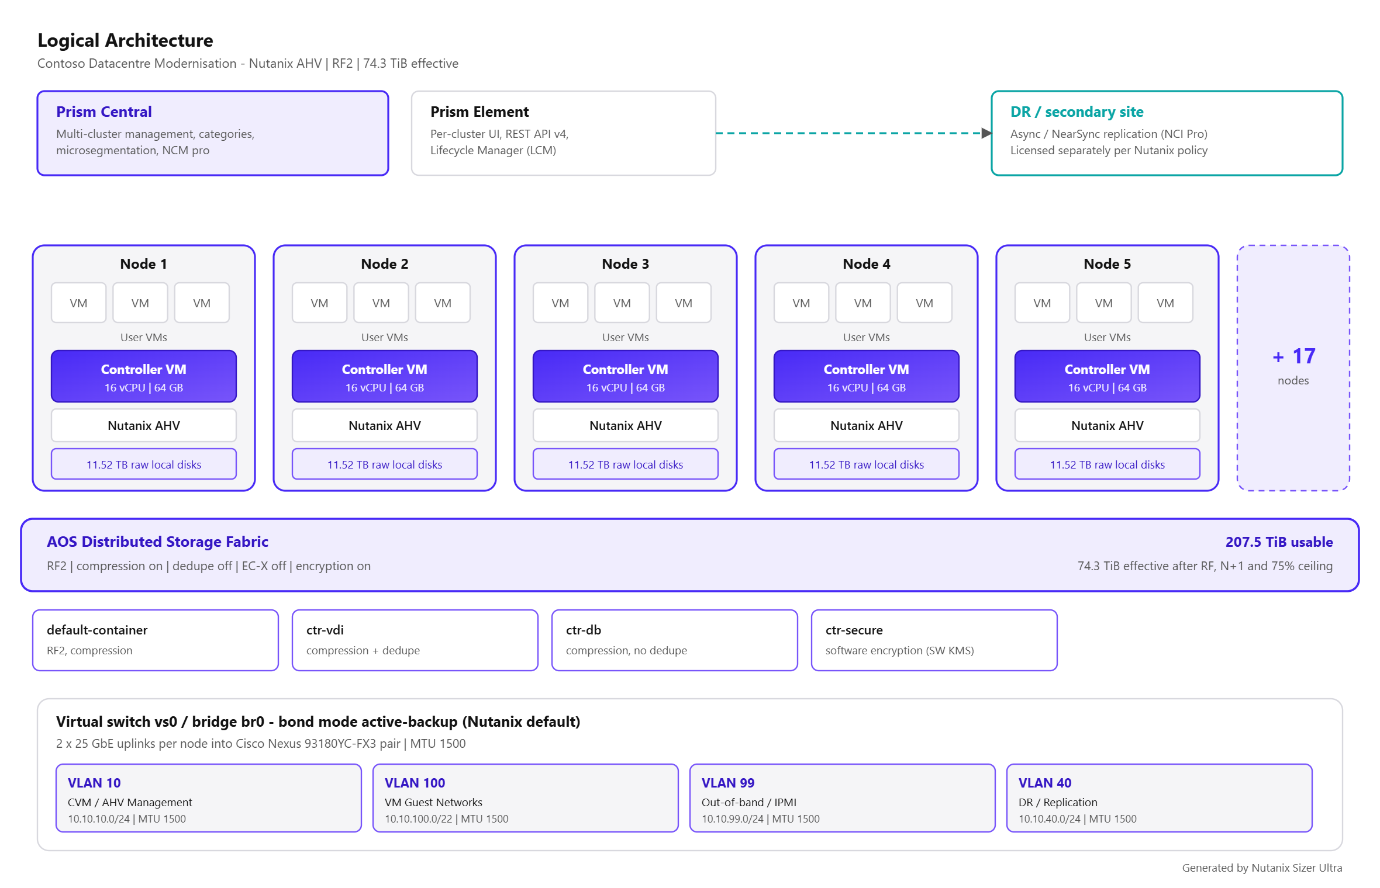
Figure 7 - Logical architecture diagram

6. Licensing
Recommended edition: NCI Pro - Powerful feature set suited to most production workloads. No cluster size limit (NCI 7.3+).
- Data-at-rest encryption with native KMS requires NCI Pro or higher.
- Cluster of 22 nodes exceeds the 12-node NCI Starter limit.
- Multi-site Async / MST replication requires NCI Pro.

6.1 Licence line items
Nutanix does not publish list pricing. Quantities only - pricing is added by the partner or Nutanix account team.
SKU (generic) | Product | Metric | Quantity | Term (months) | Notes
NCI-PRO-CORE | NCI Pro | Physical CPU core | 1,408 | 36 | 22 nodes x 2 sockets x 32 cores. Must cover 100% of cluster cores.
NCM-PRO-CORE | NCM Pro | Physical CPU core | 1,408 | 36 | Adds cost governance, self-service infrastructure and automation.
ADVREP-ADDON | Advanced Replication (Advanced DR) | Physical CPU core | 1,408 | 36 | Metro Availability, Sync and NearSync. Included natively in NCI Ultimate. Requires NCI Pro.

6.2 NCI edition comparison
Edition | Licensing metric | Max cluster size | Key capabilities
NCI Starter | Per physical CPU core | 12 nodes | AOS distributed storage + AHV hypervisor; Prism Element management, REST APIs, Lifecycle Manager (LCM); Nutanix Insights / Pulse; Native async Disaster Recovery, VM snapshots (1-hour minimum RPO)
NCI Pro | Per physical CPU core | No limit | Everything in Starter; Tunable redundancy - RF2 and RF3; Erasure Coding (EC-X) capacity optimisation; Data-at-rest encryption + native KMS (included from 7.3)
NCI Ultimate | Per physical CPU core | No limit | Everything in Pro; Advanced Replication - Metro Availability, Synchronous and NearSync (RPO = 0); Cross-cluster live migration; Runbook automation / orchestrated DR

7. Growth and lifecycle
Demand is modelled at 12% compound growth per year. The design point sits at year 3.
Year | vCPU | RAM (GB) | Data (TiB) | Nodes (CPU) | Nodes (RAM) | Nodes (storage) | Nodes required
0 | 2,312 | 8,888 | 73.4 | 16 | 13 | 16 | 16
1 | 2,589 | 9,955 | 82.2 | 18 | 15 | 18 | 18
2 | 2,900 | 11,149 | 92.0 | 20 | 16 | 20 | 20
3 | 3,248 | 12,487 | 103.1 | 22 | 18 | 22 | 22
4 | 3,638 | 13,985 | 115.5 | 25 | 20 | 25 | 25
5 | 4,075 | 15,664 | 129.3 | 28 | 22 | 28 | 28
[diagram unavailable]
Figure 8 - Growth projection

8. Nutanix best practices applied

Server Virtualisation
- Size every RF2 cluster for N+1 on BOTH compute and storage so a failed node can be fully rebuilt and its VMs restarted.
- Minimum 3 nodes for RF2. Use RF3 (minimum 5 nodes) where a double failure must be survivable.
- Keep a uniform node model inside a cluster; mixed models are supported but the cluster inherits the lowest common capability.
- Default CVM allocation is 12 vCPU / 32 GB RAM. All CVM vCPUs must fit inside a single NUMA socket.
- Do not exceed roughly 4:1 vCPU-to-physical-core for general server workloads before validating with real utilisation data.
- Enable inline compression on all containers; it is on by default and costs almost nothing on modern CPUs.
- Use one storage container per policy (compression/EC/encryption), not one per application.

VDI / End-User Computing
- All-flash is strongly recommended for VDI; boot and logon storms are latency-bound, not capacity-bound.
- If performance-tier deduplication is enabled, raise CVM memory to 24 GB minimum; inline compression alone needs 16 GB.
- Typical density planning: 6:1 vCPU-to-core for knowledge workers, 4:1 for power users, 8:1+ only for task workers.
- Size for a 20-25% CPU headroom so a boot storm or a node failure does not saturate the surviving hosts.
- Use instant/linked clones so Nutanix deduplication and Shadow Clones can serve the golden image from every node.
- Separate the VDI cluster from server workloads when the desktop count exceeds roughly 1,000 seats.
- For vGPU-backed desktops select a GPU-capable platform and NCI Pro or higher (vGPU is a Pro feature).

Databases & Business Critical Apps
- Nutanix recommends 16 vCPU and 64 GB RAM for the CVM on storage-heavy database nodes (minimum 12 vCPU).
- Increase CVM memory to 64 GB for heavy I/O to enlarge the metadata cache and reduce latency.
- All CVM vCPUs must fit within a single socket - do not assign more vCPUs than the cores available on one socket.
- Do not enable deduplication for database containers; enable inline compression instead.
- Keep vCPU-to-core at or below 2:1 for tier-1 databases, and 1:1 for licence-bound or latency-critical instances.
- Use all-flash / NVMe platforms and keep the cluster below 75% storage utilisation for consistent latency.
- Align database VM vCPU counts to the physical core and NUMA topology of the node to avoid vNUMA fragmentation.
- Consider Nutanix Database Service (NDB) for provisioning, patching and copy-data management.

Private Cloud / Mixed Workload
- Use Nutanix Cloud Manager (NCM) for capacity planning, rightsizing, showback and self-service.
- Separate clusters by lifecycle (prod / non-prod) rather than by application where possible.
- Standardise on one or two node models to keep LCM, spares and licensing simple.
- Reserve 20-25% CPU and RAM headroom so rightsizing and burst do not push the cluster into contention.
- Use categories and Flow Network Security for tenant isolation (Ultimate, or Pro plus the Security add-on).
- Deploy Prism Central as a scale-out 3-VM instance for production private cloud.

Cross-cutting Nutanix design rules
- Cluster resiliency: RF2 requires a minimum of 3 nodes; RF3 requires a minimum of 5 nodes. Size N+1 (or N+2 for RF3) so a failed node's VMs restart and its data re-protects.
- Storage headroom: Keep steady-state utilisation at or below the configured ceiling. Nutanix flags Data Resiliency as critical when free space drops below the capacity needed to rebuild a node.
- CVM: Every node runs a Controller VM. Reserve its vCPU and RAM out of usable host capacity - the default is 12 vCPU / 32 GB, rising to 16 vCPU / 64 GB for database-heavy nodes.
- NUMA: All CVM vCPUs must fit inside one physical socket. Do not assign more CVM vCPUs than the cores available on a single socket.
- Data efficiency: Inline compression should be on everywhere. Deduplication suits VDI and backup, not databases. EC-X suits cold data and needs 4+ nodes (6+ recommended).
- Mixed clusters: NCI editions are set per cluster. A cluster with mixed licences defaults to the lowest tier, so licence every node in a cluster at the same edition.
- Networking: Use two leaf/ToR switches with redundant uplinks per node. Nutanix recommends active-backup bonding by default; use balance-tcp (LACP) only with a properly configured MLAG/vPC pair.
- Network speed: 10 GbE is the practical minimum; 25 GbE or faster is recommended for all-flash/NVMe nodes and for any cluster carrying database or VDI workloads.
- Out-of-band: Every node needs an IPMI/iDRAC/XCC/CIMC port on a separate management switch or VLAN for Foundation, LCM and remote console.
- Lifecycle: Standardise node models per cluster and keep AOS, AHV, firmware and Prism Central on versions validated together by Lifecycle Manager (LCM).

9. Generic bill of quantities
Placeholder SKUs. Confirm exact part numbers with the vendor or distributor before ordering. No pricing is included.

Hardware - Nutanix cluster nodes
SKU (generic) | Description | Qty | UoM | Notes
NUTANIX-NX-8170-G9-NODE | Nutanix NX-8170-G9 node - 2x CPU, 32 cores/socket, 1024 GB RAM, 11.52 TB raw storage | 22 | node | Dual Intel Xeon 5th Gen. (Emerald Rapids). All SSD SED, All NVMe SED, All SSD, NVMe+NST, All NVMe. Form factor 1U1N.
NUTANIX-CPU-32C | CPU - 32 core processor (Dual Intel Xeon 5th Gen. (Emerald Rapids)) | 44 | ea | Select the exact SKU from the vendor configurator; core count must match the licensed core count.
MEM-32GB | Memory - 32 GB DIMM | 704 | ea | 32 DIMMs per node = 1024 GB. Populate symmetrically across both sockets / all channels.
DRV-NVME | Data drives - 1.92 TB NVMe SSD | 132 | ea | 6 drives per node = 11.52 TB raw. All SSD SED, All NVMe SED, All SSD, NVMe+NST, All NVMe
NIC-25G-2P | Network adapter - 2 x 25 GbE per node | 22 | ea | Dual-port minimum, one port to each ToR switch. 25 GbE or faster recommended for all-flash nodes.
RAILKIT-STD | Rail kit / cable management arm | 22 | ea | One per chassis.
PWR-C13-C14 | Power cords (redundant PSU feeds) | 44 | ea | Two per chassis - A and B feed. Confirm the local plug type.

Network - top of rack and out of band
SKU (generic) | Description | Qty | UoM | Notes
CISCO-NEXUS93180YC-FX3 | Cisco Nexus 93180YC-FX3 - data ToR switch (48x 25G + 6x 100G) | 2 | ea | 48x 1/10/25G SFP28 + 6x 40/100G QSFP28. Common Nutanix ToR. Deployed as 1 redundant pair(s) using vPC.
CISCO-NEXUS92348GC-X-OOB | Cisco Nexus 92348GC-X - out-of-band management switch | 1 | ea | IPMI / iDRAC / XCC / CIMC / iRMC access for Foundation, LCM and remote console.
CAB-25G-SFP28 | Node-to-ToR cabling - 25G SFP28 DAC / optic + LC patch | 44 | ea | 2 per node x 22 nodes.
CAB-100G-QSFP28 | Switch uplinks to spine/core - 100G QSFP28 DAC / optic | 4 | ea | 2 uplinks per switch.
CAB-100G-QSFP28-PEER | vPC peer-link cabling between the ToR pair | 2 | ea | Required when LACP / balance-tcp bonding is used. Recommended in all cases for the peer keepalive.
CAB-1G-RJ45 | Out-of-band cabling - Cat6A copper patch (RJ45) | 22 | ea | One IPMI/BMC port per node.

Nutanix software licences
SKU (generic) | Description | Qty | UoM | Notes
NCI-PRO-CORE | NCI Pro - Physical CPU core | 1408 | Physical CPU core | 22 nodes x 2 sockets x 32 cores. Must cover 100% of cluster cores. Term: 36 months.
NCM-PRO-CORE | NCM Pro - Physical CPU core | 1408 | Physical CPU core | Adds cost governance, self-service infrastructure and automation. Term: 36 months.
ADVREP-ADDON | Advanced Replication (Advanced DR) - Physical CPU core | 1408 | Physical CPU core | Metro Availability, Sync and NearSync. Included natively in NCI Ultimate. Requires NCI Pro. Term: 36 months.

Support and services
SKU (generic) | Description | Qty | UoM | Notes
SUPPORT-PRODUCTION-36M | Nutanix Production support - hardware and software | 22 | node | 36 month term, co-termed with the software licences.
SVC-FOUNDATION-DEPLOY | Deployment services - Foundation imaging, cluster creation, Prism Central, network integration | 1 | engagement | Sized for a 22-node cluster across 22 chassis at 2 site(s).
SVC-MIGRATION-MOVE | Workload migration services (Nutanix Move / cross-hypervisor conversion) | 9 | wave of 100 VMs | 834 VMs in scope.
SVC-KNOWLEDGE-TRANSFER | Administrator knowledge transfer / handover workshop | 1 | engagement | Prism Element and Prism Central operations, LCM, DR runbook.

Facilities (informational)
SKU (generic) | Description | Qty | UoM | Notes
RACK-U | Rack units consumed by Nutanix nodes | 22 | RU | 22 x 1U1N chassis. Add 3 RU for switches.
PWR-KW | Estimated peak power draw | 21.8 | kW | 991 W per node estimate. Confirm against the vendor power calculator before ordering PDUs.
COOL-BTU | Estimated heat load | 74388 | BTU/hr | Derived from the power estimate.

10. Data sources
All hardware specifications, licensing rules and best-practice guidance in this document are taken from official Nutanix sources.
- Nutanix Hardware Platform Spec Sheets - https://www.nutanix.com/products/hardware-platforms/specsheet
- Nutanix Cloud Infrastructure (NCI) datasheet - https://www.nutanix.com/library/datasheets/nci
- Nutanix licensing and software options - https://www.nutanix.com/products/cloud-platform/software-options
- Nutanix Cloud Manager (NCM) datasheet - https://www.nutanix.com/library/datasheets/ncm
- Nutanix CVM considerations, Microsoft SQL Server on Nutanix best practice guide (BP-2015)
- Oracle on Nutanix best practice guide (BP-2000) - Nutanix configuration
- Nutanix Hybrid Cloud Reference Architecture - compute and storage

