Head office VDI endpoint refresh
Thin client selection and design
Customer | Niyyasoft
Site | Riyadh HQ
Prepared by | Niyyasoft
Date | 30 September 2026
Recommendation | 263 x Dell Pro Micro Thin Client (Q9M1260) · 100% fit · meets every requirement

Prepared with the Zero/Thin Client Selector by Niyya Software. Specifications are taken from each OEM's official website.

1. Executive summary
For 250 knowledge worker seats on Citrix, the tool scored 233 current models from 29 OEMs against 2 x Full HD displays, a 1 GbE network, optimised Microsoft Teams and the ports, peripherals, management and security asked for. The recommended endpoint is the Dell Pro Micro Thin Client (Q9M1260) from Dell Technologies, running Dell ThinOS 10.x, at 100% fit. It meets every stated requirement on the OEM's published data. 263 endpoints are needed (250 seats plus 13 spares). 22 of the 233 models meet every requirement and 64 more need a value confirming.
Endpoints | 263 (250 seats + 13 spares)
Device | Dell Pro Micro Thin Client (Q9M1260) - Thin client · Desktop box
Operating system | Dell ThinOS 10.x
Fit | 100% - meets every requirement
Platform and protocol | Citrix over Citrix HDX (ICA)
Processor and memory | Intel Processor N150 (4 cores, up to 3.6 GHz); Intel Processor N250 (4 cores, up to 3.8 GHz); Intel Core 3 Processor N350 (8 cores, up to 3.9 GHz) · 8 - 16 GB DDR5 SO-DIMM (1 module, 4800 MT/s)
Displays | 5 displays, up to 3840x2160@60 · 2 x DisplayPort, 1 x USB-C (DP Alt)
USB and network | 3 x USB 2.0, 1 x USB 3.x, 2 x USB-C · 1 GbE, Wi-Fi 7
VDI platforms | Citrix, Omnissa Horizon, Azure Virtual Desktop, Windows 365, Microsoft RDS, Amazon WorkSpaces, HP Anyware, Parallels RAS, Frame, Workspot, Leostream
Optimised UC | Microsoft Teams, Zoom, Cisco Webex, Cisco Jabber, Skype for Business
Management | Wyse Management Suite
Official source | https://www.dell.com/en-us/shop/wyse-endpoints-and-software/dell-pro-micro-thin-client/spd/dell-pro-q9m1260-thin-client-micro

2. Requirements
Item | Requirement
Use case | Knowledge worker - 250 users, 5% spares, 80% signed in at peak
VDI platform | Citrix DaaS / Virtual Apps and Desktops - virtual desktops (VDI)
Display protocol | Citrix HDX (ICA) (the platform's own)
Device | Type: thin or zero client; form factor: desktop box; operating system: any
Displays | 2 x Full HD (1920 x 1080) per seat; preferred port: any
Processor, memory, storage | At least 4 cores, 8 GB memory, 16 GB storage (the tool's baseline for this use case)
Network | 1 GbE wired; Wired only; Office, on the campus LAN
Connectivity options | None
USB and ports | At least 4 USB ports
Unified communications | Microsoft Teams - optimised on the endpoint
Peripherals | Webcam, Headset, Printer
Management and security | Central management software, TPM 2.0
OEMs considered | All (35)

3. How it was worked out
Step | Working
Seats | 250 users + 5% spares (13) = 263 endpoints to buy
Per-seat baseline | Knowledge worker baseline: 4 cores, 8 GB. A planning rule of thumb, not an OEM figure.
Per-seat minimum used | 4 cores, 8 GB memory, 16 GB storage
Displays | 2 x Full HD per seat = 500 screens in total
USB at the desk | 4 devices: Keyboard, Mouse, Webcam, Headset
Session bandwidth | 0.9 Mbps average per session (knowledge worker, 2 displays at Full HD) x 200 concurrent users (80%) + 50 in calls at 1.5 Mbps = about 255 Mbps on the site uplink. A planning estimate - measure a pilot before sizing the WAN.
Access network | 250 wired ports at 1 GbE; 6 x 48-port access switches with 10% spare ports

Every model is scored 0-100 on each criterion that applies and the scores are weighted into the fit percentage. A hard mismatch - wrong device type, platform not supported, too few displays, no Wi-Fi when Wi-Fi is the link - caps the fit at 49%. A value the OEM does not publish is listed as "to confirm" and scored low.

4. Recommended device
Dell Pro Micro Thin Client (Q9M1260)
Thin client · Desktop box · Dell ThinOS 10.x
Dell's current fanless micro thin client with up to an 8-core Intel N-series CPU, a swappable rear expansion module (fibre, second NIC, serial, extra video) and support for up to five displays.

Fit breakdown
Criterion | Weight | Score
VDI platform & protocol | 20 | 100%
Device type & OS | 9 | 100%
Displays | 14 | 100%
CPU, memory & storage | 13 | 100%
Network & connectivity | 10 | 100%
USB & ports | 7 | 100%
Teams / UC, camera & audio | 10 | 100%
Peripherals | 5 | 100%
Management & security | 6 | 100%
Use-case suitability | 4 | 100%
Model currency | 2 | 100%

Bill of materials
Item | Specification | Quantity
Endpoint | Dell Pro Micro Thin Client (Q9M1260) (Thin client · Desktop box) - 250 seats + 13 spares | 263
Operating system | Dell ThinOS 10.x | 263
Memory | 8 GB DDR5 SO-DIMM (1 module, 4800 MT/s) | 263
Storage | At least 16 GB - 128 GB UFS (M.2 2230) or 256 GB M.2 2230 PCIe NVMe SSD | 263
Monitor | Full HD (1920 x 1080) monitor, 2 per seat | 500
Video cable | To match the device outputs: 2 x DisplayPort, 1 x USB-C (DP Alt) | 500
Keyboard and mouse | USB keyboard and mouse set | 250
Webcam | USB webcam (UVC), Full HD | 250
Headset | Microsoft Teams-certified headset, USB or 3.5 mm | 250
Management software | Wyse Management Suite - one managed device each | 263
VDI client | Citrix Workspace app for Citrix, as included with or installed on Dell ThinOS 10.x | 263
Access switch port | 1 GbE port and patch cable | 250

5. Logical design
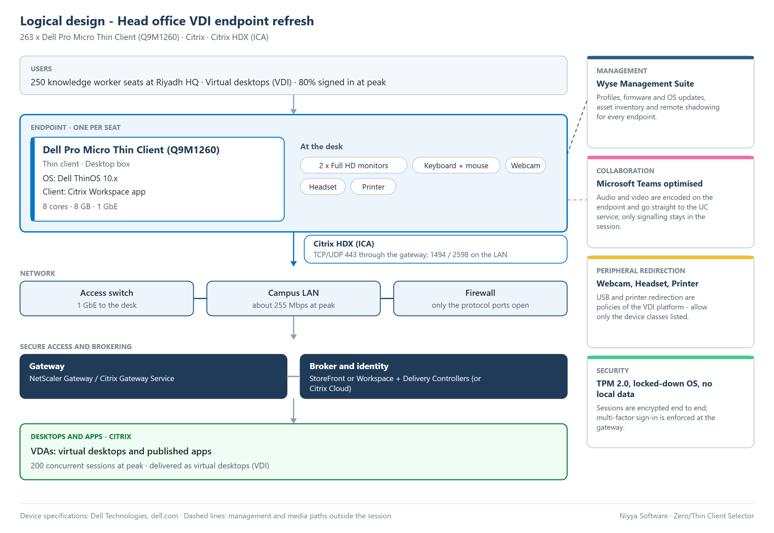
Figure 1 - Logical design. Users, the endpoint and its peripherals, the network, gateway and broker, desktops and apps, with management, collaboration and security.

6. Implementation design
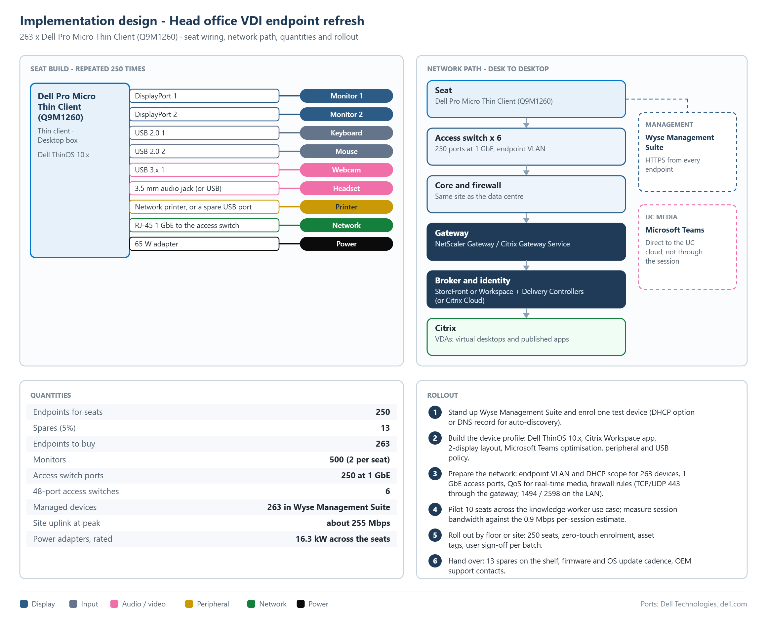
Figure 2 - Implementation design. Seat wiring by port, the network path from desk to desktop, quantities and rollout.

Port plan per seat
Connects | Port on the device
Monitor 1 | DisplayPort 1
Monitor 2 | DisplayPort 2
Keyboard | USB 2.0 1
Mouse | USB 2.0 2
Webcam | USB 3.x 1
Headset | 3.5 mm audio jack (or USB)
Printer | Network printer, or a spare USB port
Network | RJ-45 1 GbE to the access switch
Power | 65 W adapter

Quantities
Item | Quantity
Endpoints for seats | 250
Spares (5%) | 13
Endpoints to buy | 263
Monitors | 500 (2 per seat)
Access switch ports | 250 at 1 GbE
48-port access switches | 6
Managed devices | 263 in Wyse Management Suite
Site uplink at peak | about 255 Mbps
Power adapters, rated | 16.3 kW across the seats

Rollout
1. Stand up Wyse Management Suite and enrol one test device (DHCP option or DNS record for auto-discovery).
2. Build the device profile: Dell ThinOS 10.x, Citrix Workspace app, 2-display layout, Microsoft Teams optimisation, peripheral and USB policy.
3. Prepare the network: endpoint VLAN and DHCP scope for 263 devices, 1 GbE access ports, QoS for real-time media, firewall rules (TCP/UDP 443 through the gateway; 1494 / 2598 on the LAN).
4. Pilot 10 seats across the knowledge worker use case; measure session bandwidth against the 0.9 Mbps per-session estimate.
5. Roll out by floor or site: 250 seats, zero-touch enrolment, asset tags, user sign-off per batch.
6. Hand over: 13 spares on the shelf, firmware and OS update cadence, OEM support contacts.

7. Alternatives from other OEMs
The best-fitting model from each OEM for the same requirements.
OEM | Model | Type | Fit | Status | To resolve
Dell | Dell Pro Micro Thin Client (Q9M1260) | Thin client · Desktop box | 100% | Meets | -
HP | HP Elite t655 Thin Client | Thin client · Desktop box | 100% | Meets | -
Praim | Meridian (M9354 / M9311 / M9321) | Thin client · Desktop box | 99% | Meets | -
10ZiG | 7300q Series (7372q / 7311q) | Thin client · Desktop box | 98% | Meets | -
Lenovo | ThinkCentre M75q Gen 5 | Thin client · Desktop box | 97% | Meets | -
LG | CQ601 (CQ601N / CQ601I / CQ601W) | Thin client · Desktop box | 97% | Meets | -
Centerm | D650 | Thin client · Desktop box | 97% | To confirm | Confirm: optimised Microsoft Teams on Windows IoT is inferred, not stated by the OEM
ZeeTim | ZeeTerm ZTX6002 | Thin client · Desktop box | 97% | To confirm | Confirm: tPM is not published
NComputing | EX500S | Thin client · Desktop box | 96% | To confirm | Confirm: tPM is not published
Rangee | Rangee Thin Client RT-603 | Thin client · Desktop box | 96% | To confirm | Confirm: tPM is not published
ClearCube | CD8810 | Thin client · Desktop box | 96% | To confirm | Confirm: tPM is not published
Atrust | t175W | Thin client · Desktop box | 96% | To confirm | Confirm: optimised Microsoft Teams on Windows IoT is inferred, not stated by the OEM
Chip PC | iX PC Core Wifi | Thin client · Desktop box | 95% | To confirm | Confirm: optimised Microsoft Teams on Windows IoT is inferred, not stated by the OEM; Confirm: tPM is not published
Leadtek | EL4115 Ultra-Thin Client | Thin client · Desktop box | 95% | To confirm | Confirm: optimised Microsoft Teams on Windows IoT is inferred, not stated by the OEM; Confirm: tPM is not published
Fujitsu | ESPRIMO G6016-TC | Thin client · Desktop box | 95% | To confirm | Confirm: optimised Microsoft Teams on Windows IoT is inferred, not stated by the OEM; Confirm: no central management software is named by the OEM
Amulet Hotkey | DX1500 | Thin client · Desktop box | 94% | To confirm | Confirm: processor core count is not published
OnLogic | TM260 | Zero client · Desktop box | 91% | To confirm | Confirm: optimised Microsoft Teams support is not published; Confirm: tPM is not published
Clientron | G610 | Thin client · Desktop box | 90% | To confirm | Confirm: optimised Microsoft Teams on Windows IoT is inferred, not stated by the OEM; Confirm: no central management software is named by the OEM
openthinclient | ThinClient BLACK.QUADRO.II | Thin client · Desktop box | 88% | To confirm | Confirm: wired Ethernet speed is not published; Confirm: optimised Microsoft Teams support is not published; Confirm: tPM is not published
Pepperl+Fuchs | BTC22 | Thin client · Desktop box | 84% | Short | 1 USB port; 4 needed; Confirm: processor core count is not published; Confirm: tPM is not published
epatec | Thin Client 13G | Thin client · Desktop box | 83% | Short | 4 GB memory at most; 8 GB recommended for this use case; Confirm: maximum resolution is not published; Confirm: processor core count is not published; Confirm: no central management software is named by the OEM; Confirm: tPM is not published
RDP | RDP Thin Client C212261 | Thin client · Desktop box | 79% | Short | 1 USB port; 4 needed; Confirm: maximum resolution is not published; Confirm: processor core count is not published; Confirm: optimised Microsoft Teams on Windows IoT is inferred, not stated by the OEM; Confirm: no central management software is named by the OEM; Confirm: tPM is not published
Raspberry Pi | Raspberry Pi 500 | Thin client · Desktop box | 77% | Short | 3 USB ports; 4 needed; Confirm: vDI platform support is not published by the OEM; Confirm: optimised Microsoft Teams support is not published; Confirm: no central management software is named by the OEM; Confirm: tPM is not published
Advantech | TPC-312 EHL | Thin client · All-in-one 12.1" | 49% | Short | Is all-in-one, not desktop box; Confirm: number of displays supported is not published; Confirm: maximum resolution is not published; Confirm: optimised Microsoft Teams on Windows IoT is inferred, not stated by the OEM
Microsoft | Windows 365 Link | Thin client · Desktop box | 49% | Short | No Citrix support published (lists Windows 365); Confirm: processor core count is not published; Confirm: optimised Microsoft Teams support is not published
Rockwell | ASEM 6300T-BB Dual DisplayPort Thin Client | Zero client · Desktop box | 49% | Short | No Citrix support published (lists Other); Confirm: optimised Microsoft Teams support is not published; Confirm: tPM is not published
IGEL | IGEL UD Pocket 2 | Thin client · Stick / board | 49% | Short | Is stick / board, not desktop box; 0 USB ports; 4 needed; No USB port for a webcam; No audio jack or USB port for a headset; No port for a printer; Confirm: number of displays supported is not published; Confirm: maximum resolution is not published; Confirm: processor core count is not published; Confirm: memory is not published; Confirm: wired Ethernet speed is not published; Confirm: tPM is not published
vCloudPoint | V1 | Zero client · Desktop box | 49% | Short | No Citrix support published (lists vCloudPoint vMatrix); Drives 1 display; 2 needed; Confirm: optimised Microsoft Teams support is not published; Confirm: tPM is not published
Thinvent | Thinvent Micro 6 Pro | Thin client · Desktop box | 49% | Short | No Citrix support published (lists Microsoft RDP, Terminal emulation, Browser / HTML5); Drives 1 display; 2 needed; 4 GB memory at most; 8 GB recommended for this use case; 100 Mb Ethernet; 1 GbE needed; 2 USB ports; 4 needed; Confirm: maximum resolution is not published; Confirm: optimised Microsoft Teams support is not published; Confirm: tPM is not published

Top of the ranking
# | OEM | Model | Type | Fit | Status
1 | Dell | Dell Pro Micro Thin Client (Q9M1260) | Thin client · Desktop box | 100% | Meets
2 | HP | HP Elite t655 Thin Client | Thin client · Desktop box | 99.8% | Meets
3 | HP | HP Elite t660 Thin Client | Thin client · Desktop box | 99.8% | Meets
4 | HP | HP Pro t550 Thin Client | Thin client · Desktop box | 99.8% | Meets
5 | HP | HP ProDesk 5 G1i Thin Client | Thin client · Desktop box | 99.8% | Meets
6 | Praim | Meridian (M9354 / M9311 / M9321) | Thin client · Desktop box | 99.2% | Meets
7 | 10ZiG | 7300q Series (7372q / 7311q) | Thin client · Desktop box | 98.4% | Meets
8 | 10ZiG | 7000q Series (7072q / 7010q / 7011q) | Thin client · Desktop box | 98.2% | Meets
9 | HP | HP Elite t755 Thin Client | Thin client · Desktop box | 98% | Meets
10 | Praim | Neutrino (N9254 / N9211 / N9221) | Thin client · Desktop box | 97.8% | Meets
11 | Lenovo | ThinkCentre M75q Gen 5 | Thin client · Desktop box | 97.4% | Meets
12 | Lenovo | ThinkCentre neo 50q Gen 5 | Thin client · Desktop box | 97.4% | Meets
13 | Lenovo | ThinkCentre neo 55q Gen 6 | Thin client · Desktop box | 97.4% | Meets
14 | Lenovo | ThinkEdge SE10n Gen2 | Thin client · Desktop box | 97.4% | Meets
15 | Lenovo | ThinkEdge SE30n Gen2 | Thin client · Desktop box | 97.4% | Meets
16 | Praim | Zenith (Z9354 / Z9311) | Thin client · Desktop box | 97.4% | Meets
17 | Lenovo | ThinkEdge SE10 | Thin client · Desktop box | 97.2% | Meets
18 | Lenovo | ThinkCentre M70q Gen 5 | Thin client · Desktop box | 96.7% | Meets
19 | Lenovo | ThinkCentre M70q Gen 6 | Thin client · Desktop box | 96.7% | Meets
20 | LG | CQ601 (CQ601N / CQ601I / CQ601W) | Thin client · Desktop box | 96.6% | Meets

8. Model comparison
Recommended from the comparison: Dell Pro Micro Thin Client (Q9M1260) at 100% fit.
 | Dell Pro Micro Thin Client (Q9M1260) | HP Elite t655 Thin Client | Praim Meridian (M9354 / M9311 / M9321) | 10ZiG 7300q Series (7372q / 7311q) | Lenovo ThinkCentre M75q Gen 5
Fit | 100% | 99.8% | 99.2% | 98.4% | 97.4%
Status | Meets | Meets | Meets | Meets | Meets
VDI platform & protocol | 100% | 100% | 100% | 100% | 100%
Device type & OS | 100% | 100% | 100% | 100% | 100%
Displays | 100% | 100% | 100% | 100% | 100%
CPU, memory & storage | 100% | 100% | 100% | 100% | 100%
Network & connectivity | 100% | 100% | 100% | 100% | 100%
USB & ports | 100% | 100% | 100% | 100% | 100%
Teams / UC, camera & audio | 100% | 100% | 94% | 94% | 92%
Peripherals | 100% | 100% | 100% | 80% | 80%
Management & security | 100% | 100% | 100% | 100% | 100%
Use-case suitability | 100% | 100% | 100% | 100% | 82%
Model currency | 100% | 90% | 90% | 100% | 100%
Type | Thin client · Desktop box | Thin client · Desktop box | Thin client · Desktop box | Thin client · Desktop box | Thin client · Desktop box
Operating systems | Dell ThinOS, Windows IoT Enterprise | Vendor Linux, Windows IoT Enterprise, IGEL OS | Vendor Linux, Windows IoT Enterprise | Vendor Linux, Windows IoT Enterprise | IGEL OS, Windows IoT Enterprise
Processor | Intel Processor N150 (4 cores, up to 3.6 GHz); Intel Processor N250 (4 cores, up to 3.8 GHz); Intel Core 3 Processor N350 (8 cores, up to 3.9 GHz) | AMD Ryzen Embedded R2314 (4 cores / 4 threads, 2.1 GHz base, up to 3.5 GHz) | Intel N97 Quad-Core up to 3.6GHz (Alder Lake) | Intel N100 Quad Core up to 3.40GHz | AMD Ryzen 3 / 5 8000 or Ryzen 3 / 5 / 7 PRO 8000 Series, up to Ryzen 7 PRO 8700G / 8700GE
Memory | 8 - 16 GB DDR5 SO-DIMM (1 module, 4800 MT/s) | 4 - 32 GB DDR4 SODIMM (dual channel, 2 slots, up to 2667 MT/s) | 8 - 16 GB | 8 - 16 GB | 64 GB DDR5-5200 SO-DIMM (two slots; 32GB standard maximum, 64GB by special bid)
Displays / max resolution | 5 / 3840x2160@60 | 3 / 3840x2160@60 | 3 / 4096x2160@60 | 3 / 4096x2160@60 | 4 / 4096x2160@60
Video outputs | 2 x DisplayPort, 1 x USB-C (DP Alt) | 3 x DisplayPort | 3 x DisplayPort | 2 x HDMI, 1 x USB-C (DP Alt) | 1 x DisplayPort, 1 x HDMI
USB | 3 x USB 2.0, 1 x USB 3.x, 2 x USB-C | 2 x USB 2.0, 4 x USB 3.x, 1 x USB-C | 4 x USB 2.0, 2 x USB 3.x, 2 x USB-C | 2 x USB 2.0, 2 x USB 3.x, 1 x USB-C | 3 x USB 2.0, 3 x USB 3.x, 1 x USB-C
Network | 1 GbE, Wi-Fi 7 | 1 GbE, Wi-Fi 6 | 1 GbE, Wi-Fi 6E | 1 GbE, Wi-Fi 6 | 1 GbE, Wi-Fi 7
VDI platforms | Citrix, Omnissa Horizon, Azure Virtual Desktop, Windows 365, Microsoft RDS, Amazon WorkSpaces, HP Anyware, Parallels RAS, Frame, Workspot, Leostream | Citrix, Omnissa Horizon, Microsoft RDS, Azure Virtual Desktop, Windows 365, Amazon WorkSpaces, HP Anyware, Parallels RAS, Frame, Workspot, Leostream | Citrix, Omnissa Horizon, Microsoft RDS, Azure Virtual Desktop, Parallels RAS, Windows 365, Amazon WorkSpaces, HP Anyware, Frame, Workspot, Leostream | Citrix, Omnissa Horizon, Azure Virtual Desktop, Windows 365, Microsoft RDS, Amazon WorkSpaces, HP Anyware, Parallels RAS, Frame, Workspot, Leostream | Citrix, Omnissa Horizon, Azure Virtual Desktop, Windows 365, Amazon WorkSpaces, Microsoft RDS, HP Anyware, Parallels RAS, Frame, Workspot, Leostream
Optimised UC | Microsoft Teams, Zoom, Cisco Webex, Cisco Jabber, Skype for Business | Microsoft Teams, Zoom, Cisco Webex, Cisco Jabber, Skype for Business | Microsoft Teams, Zoom, Cisco Webex | Microsoft Teams, Zoom, Cisco Webex, Cisco Jabber | Microsoft Teams, Zoom, Cisco Webex, Cisco Jabber, Skype for Business
Management | Wyse Management Suite | HP Wolf Cloud Endpoint Manager (HP Cloud Endpoint Manager); HP Device Manager | ThinMan | 10ZiG Manager | IGEL management (IGEL Cloud Gateway) when ordered with IGEL OS

9. Assumptions and sources
- Specifications were read from each OEM's own website; options vary by region and change with OS and firmware releases.
- A value an OEM does not publish is shown as "to confirm" and scored low - it is never assumed to be supported.
- Platform or Teams support marked "via OS" is what the operating system's vendor lists; "inferred" means Windows IoT Enterprise runs the Windows client and the OEM does not state it itself.
- The per-seat CPU and memory baseline and the bandwidth figures are planning rules of thumb, not OEM figures - validate them in a pilot.
- USB and printer redirection, and optimised Teams, Zoom or Webex, also depend on the VDI platform version and its policies.
- Licences for the VDI platform, Microsoft 365 and the endpoint operating system are outside the scope of this selection.

Official sources
Model | Official product page | Datasheet
Dell Pro Micro Thin Client (Q9M1260) | https://www.dell.com/en-us/shop/wyse-endpoints-and-software/dell-pro-micro-thin-client/spd/dell-pro-q9m1260-thin-client-micro | https://www.delltechnologies.com/asset/en-us/products/thin-clients/briefs-summaries/dell-pro-micro-thin-client-product-brochure.pdf
HP Elite t655 Thin Client | https://h20195.www2.hp.com/v2/GetDocument.aspx?docname=c08327446 | https://h20195.www2.hp.com/v2/GetDocument.aspx?docname=c08623616
Praim Meridian (M9354 / M9311 / M9321) | https://www.praim.com/en/solutions/thinclient/meridian/ | https://www.praim.com/wp-content/uploads/2025/04/Meridian-datasheet-Praim-REV.EN-2025-04-01.pdf
10ZiG 7300q Series (7372q / 7311q) | https://www.10zig.com/product/solutions/thin-clients/7300q-series/ | https://www.10zig.com/wp-content/uploads/2026/08/7300q-Series-Spec-Sheet-8_28_26.pdf
Lenovo ThinkCentre M75q Gen 5 | https://psref.lenovo.com/Product/ThinkCentre/ThinkCentre_M75q_Gen_5 | https://psref.lenovo.com/syspool/Sys/PDF/ThinkCentre/ThinkCentre_M75q_Gen_5/ThinkCentre_M75q_Gen_5_Spec.pdf
LG CQ601 (CQ601N / CQ601I / CQ601W) | https://www.lg.com/global/business/monitors-pcs/thin-clients/desktop-thin-clients/cq601w/ | https://media.us.lg.com/m/477f7ca62f07dbc6/original/CQ601W-BP-Spec-Sheet.pdf
Centerm D650 | https://www.centermclient.com/uploads/Centerm-D650-datasheet.pdf | https://www.centermclient.com/uploads/Centerm-D650-datasheet.pdf
ZeeTim ZeeTerm ZTX6002 | https://zeetim.com/products/thin-client-zeeterm | -
NComputing EX500S | https://www.ncomputing.com/documentation/datasheet/ex500w-datasheet/249046 | https://ncomputing.box.com/shared/static/f4xx38z27g20z40f6b4z73b71x7alvq3.pdf
Rangee Thin Client RT-603 | https://rangee.com/en/rangee-thin-client-rt-603/ | https://rangee.com/wp-content/uploads/2026/02/Rangee_Datasheet_RT-603_EN-1.pdf
ClearCube CD8810 | https://clearcube.com/products/thin-clients/cd8810/ | https://images.clearcube.com/wp-content/uploads/2026/03/04155516/DS-Thin-Client-CD8810.pdf
Atrust t175W | https://www.atrustcorp.com/products/t175w/ | https://www.atrustcorp.com/wp-content/uploads/2022/04/t175W-Specification.pdf
Chip PC iX PC Core Wifi | https://chippc.com/product/ix-pc-mini-5100-wifi-thinx-os/ | -
Leadtek EL4115 Ultra-Thin Client | https://www.leadtek.com/eng/products/virtual_DS(24)/EL4115_Ultra-Thin_Client(40986)/detail | -
Fujitsu ESPRIMO G6016-TC | https://jp.fujitsu.com/platform/pc/product/specific_use/thinclient_model/g6016tc/spec.html | -
Amulet Hotkey DX1500 | https://www.amulethotkey.com/product/dx1500/ | https://www.amulethotkey.com/wp-content/uploads/2026/02/DX1500-Datasheet-v1.0.pdf
OnLogic TM260 | https://www.onlogic.com/store/tm260/ | https://media.onlogic.com/248f8472-1b41-4a43-9f88-4aee598a9ac5/ddd8c62e-1eeb-405c-b13c-699c411b5cee/8GG6HTdcH8XAbyUfOD7BuackD/VJHfXNYmoYIRWxPkHJf44g5bH.pdf
Clientron G610 | https://www.clientron.com/en/product.php?act=view&id=79 | https://www.clientron.com/data/file/202607/1784518880441507258.pdf
openthinclient ThinClient BLACK.QUADRO.II | https://openthinclient.com/en/product-2/nvidia-quadro-2-thin-client/ | -
Pepperl+Fuchs BTC22 | https://www.pepperl-fuchs.com/en/landingpage/explosion-protection/industrial-box-thin-client-btc-gp27893 | https://files.pepperl-fuchs.com/webcat/navi/productInfo/doct/tdoct9440__eng.pdf?v=19-SEP-24
epatec Thin Client 13G | https://www.epatec.de/shop/thin-client-13g-70 | -
RDP Thin Client C212261 | https://rdp.in/corporate/thin-clients | -
Raspberry Pi 500 | https://www.raspberrypi.com/products/raspberry-pi-500/ | https://pip.raspberrypi.com/documents/RP-008349-DS-raspberry-pi-500-product-brief.pdf
Advantech TPC-312 EHL | https://www.advantech.com/en-us/products/2f7a6598-a2be-40d6-b615-adb84b164442/tpc-312-ehl/mod_b7f4615d-4c5f-469b-9cbc-1b4a8a27719a | https://advdownload.advantech.com/productfile/PIS/TPC-312%20EHL/file/TPC-300-EHL_DS(070926)20260714102324.pdf
Microsoft Windows 365 Link | https://learn.microsoft.com/en-us/windows-365/link/whats-in-the-box | -
Rockwell ASEM 6300T-BB Dual DisplayPort Thin Client | https://www.rockwellautomation.com/en-us/products/hardware/industrial-computers-monitors/6300t-box-thin-client.html | https://literature.rockwellautomation.com/idc/groups/literature/documents/td/6300-td001_-en-p.pdf
IGEL UD Pocket 2 | https://kb.igel.com/en/hardware/current/technical-specification-of-ud-pocket-2 | -
vCloudPoint V1 | https://www.vcloudpoint.com/zero-clients/zero-client-comparison/ | https://www.vcloudpoint.com/wp-content/uploads/documentations/A1-S100-V1-Datasheet-EN.pdf
Thinvent Micro 6 Pro | https://www.thinvent.in/p/P-6P-o4-e64-5_2P-D-Thinux-0 | -

