

VxRail Sizing Report
VxRail refresh - core cluster
Customer | Niyyasoft
Prepared by | Niyyasoft
Date | 2026-09-20
Tool | VxRail Sizer (VXRS) 1.1.0

Planning estimate based on published Dell Technologies and VMware by Broadcom guidance. Validate with Dell before ordering.

1. Executive summary
- 5 x VxRail VE-670 (PowerEdge R670, 1U) in a standard cluster, 5U of rack space.
- Per node: 1 x 48-core CPU, 768 GB memory, 4 x 1.92 TB NVMe, 4 x 25GbE networking.
- vSAN ESA, RAID-5 FTT=1 adaptive (2+1): 34.9 TiB raw, 22.6 TiB usable (1.5:1 data reduction assumed).
- Workload: 100 VMs, 542 vCPU, 2,167 GB RAM, 20.2 TiB storage including 3-year growth and management VMs.
- Utilisation after failure: CPU 78%, memory 78%; vSAN capacity 89%. Node count driven by cpu.
- VCF licensing: 240 cores (min 16 per CPU); vSAN add-on 0 TiB.
- Network: 2 x S5248F-ON ToR (VLT pair), N3248TE-ON out-of-band switch.

2. Workloads
Workload group | VMs | vCPU | RAM GB | Storage TiB
General purpose VMs | 100 | 400 | 1,600.00 | 14.65

Demand including growth and management VMs
Component | vCPU | RAM GB | Storage GB
Workloads | 400 | 1,600 | 15,000
Growth x1.331 | 132 | 530 | 4,965
vCenter Server appliance (Small) | 4 | 21 | 734
VxRail Manager VM | 6 | 16 | 0
Total | 542 | 2,167 | 20,699

3. Design policies
Parameter | Value
Cluster type | standard
vSAN architecture / release | ESA / 9.0
Storage policy | RAID-5 FTT=1 adaptive (2+1)
Data reduction assumption | 1.5:1
+1 host for rebuild | Yes
HA (compute) | N+1
vCPU : pCore | 4:1
Max CPU utilisation | 80%
vSAN CPU overhead | 10%
Memory overcommit | 1:1
Max memory utilisation | 90%
ESXi + vSAN memory reserve | 10%
Growth | 10% per year for 3 years
vCenter on cluster | Small
VMware subscription | VMware Cloud Foundation

4. Recommended VxRail configuration
Item | Qty | Detail
VxRail VE-670 node | 5 | PowerEdge R670, 1U
Processor | 5 | 1 x Intel Xeon 6 - 48 cores (48 cores) per node
Memory | 5 | 768 GB per node
vSAN ESA NVMe drives | 20 | 4 x 1.92 TB NVMe per node
Network ports | 20 | 4 x 25GbE per node (OCP + PCIe)
Boot device | 5 | Dell BOSS (mirrored M.2) per node

Capacity
Metric | Value
Physical cores | 240
Memory | 3,840 GB
Raw capacity | 38.40 TB (34.92 TiB)
Operations reserve + host rebuild reserve | -12.30 TiB
After protection (RAID-5 FTT=1 adaptive (2+1)) | 15.08 TiB
Effective usable (1.5:1) | 22.63 TiB

Utilisation and node-count drivers
Dimension | Required | Utilisation | After failure | Nodes needed
CPU | 135.6 cores | 62.8% | 78.5% | 5
Memory | 2,167 GB | 62.7% | 78.4% | 5
Storage | 20.2 TiB | 89.3% | — | 5
Policy / availability | — | — | — | 4

vSAN ReadyNode profile: vSAN-HCI-SM.

Alternatives considered
Model | Nodes | CPU | RAM/node | Storage/node | Licensed cores
VE-670 | 5 | 1 x 48c | 768 GB | 4 x 1.92 TB NVMe | 240
VP-770 | 5 | 2 x 24c | 768 GB | 4 x 1.92 TB NVMe | 240
VE-660 | 5 | 1 x 48c | 768 GB | 4 x 1.92 TB NVMe | 240
VP-760 | 5 | 2 x 24c | 768 GB | 4 x 1.92 TB NVMe | 240
VE-6615 | 5 | 1 x 48c | 768 GB | 4 x 1.92 TB NVMe | 240
VP-7625 | 5 | 2 x 24c | 768 GB | 4 x 1.92 TB NVMe | 240

5. VMware licensing
Item | Value
Edition | VCF
Physical cores | 240
Licensed cores (min 16/CPU) | 240
Included vSAN (1 TiB/core) | 240.00 TiB
Raw vSAN capacity | 34.92 TiB
vSAN add-on required | 0 TiB

6. Network design
Top-of-rack: 2 x S5248F-ON (48 x 25GbE SFP28, 4 x 100GbE QSFP28, 2 x 200GbE QSFP28-DD). VLT: QSFP28-DD 1-2; uplinks: QSFP28 1-4, 2 x 100GbE per switch.
Out-of-band: N3248TE-ON (48 x 1GbE RJ45, 4 x 10GbE SFP+, 2 x 100GbE stacking) for iDRAC.
- ✔ 10 of 48 25GbE node ports used on each S5248F-ON (21%).

VLANs
Network | VLAN | Subnet | Gateway | MTU
External management (ESXi, VxRail Manager, vCenter) | native | 192.168.10.0/24 | 192.168.10.1 | 1500
VxRail internal management (node discovery) | 3939 |  |  | 1500
vSphere vMotion | 20 | 192.168.20.0/24 |  | 9000
vSAN | 30 | 192.168.30.0/24 |  | 9000
VM / guest network | 100 | 192.168.100.0/24 | 192.168.100.1 | 1500

VDS teaming (VxRail default)
Traffic | Active | Standby
Management / vCenter | vmnic0 | vmnic1
vMotion | vmnic3 | vmnic2
vSAN | vmnic2 | vmnic3
VM networks | vmnic0 | vmnic1

Switch configuration rules
- Use two or more ToR switches for production (a single switch is acceptable for test/dev and 2-node).
- Switch buffer: at least 16 MB per ASIC for 10GbE and 32 MB for 25GbE VxRail networks.
- Configure every node-facing port as a trunk carrying all VxRail VLANs; create the internal management VLAN (default 3939) before deployment.
- Allow IPv6 multicast on the internal management VLAN for node discovery; enable MLD snooping and querier if supported.
- Disable Ethernet flow control on 10GbE and faster ports; use PFC only for RoCE or FCoE.
- Set switch-port MTU to match the VDS (9000 when jumbo frames are used for vSAN/vMotion).
- IP-hash teaming is not supported. One LAG per cluster (two ports); across two switches requires VLT/MLAG with LACP individual.
- Ports cannot be added to VxRail networking after the build; do not mix RJ45 and SFP ports in one VxRail network.
- Pair ToR switches with VLT (same model) and connect iDRAC ports to a separate 1GbE out-of-band switch.
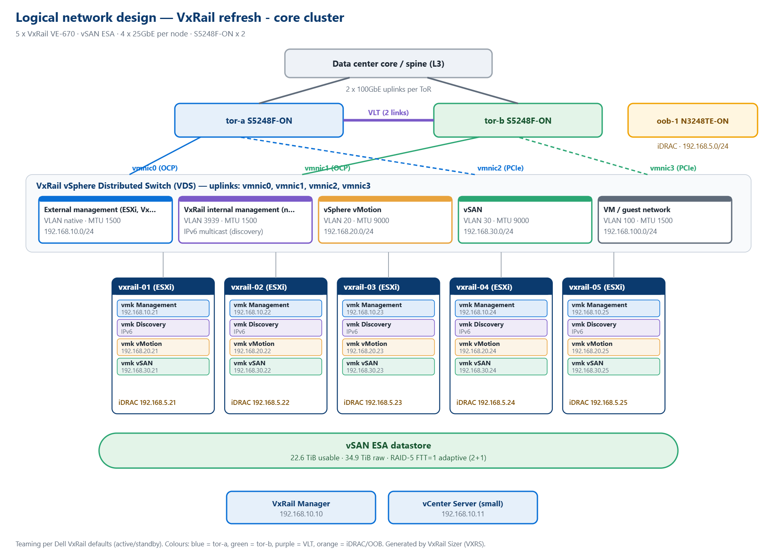
Figure 1 - Logical network design

IP address plan
Name | Role | Management | vMotion | vSAN | iDRAC
Gateway (management) | Router | 192.168.10.1
VxRail Manager | VM | 192.168.10.10
vCenter Server | VM | 192.168.10.11
vxrail-01 | ESXi host | 192.168.10.21 | 192.168.20.21 | 192.168.30.21 | 192.168.5.21
vxrail-02 | ESXi host | 192.168.10.22 | 192.168.20.22 | 192.168.30.22 | 192.168.5.22
vxrail-03 | ESXi host | 192.168.10.23 | 192.168.20.23 | 192.168.30.23 | 192.168.5.23
vxrail-04 | ESXi host | 192.168.10.24 | 192.168.20.24 | 192.168.30.24 | 192.168.5.24
vxrail-05 | ESXi host | 192.168.10.25 | 192.168.20.25 | 192.168.30.25 | 192.168.5.25

7. Physical connectivity
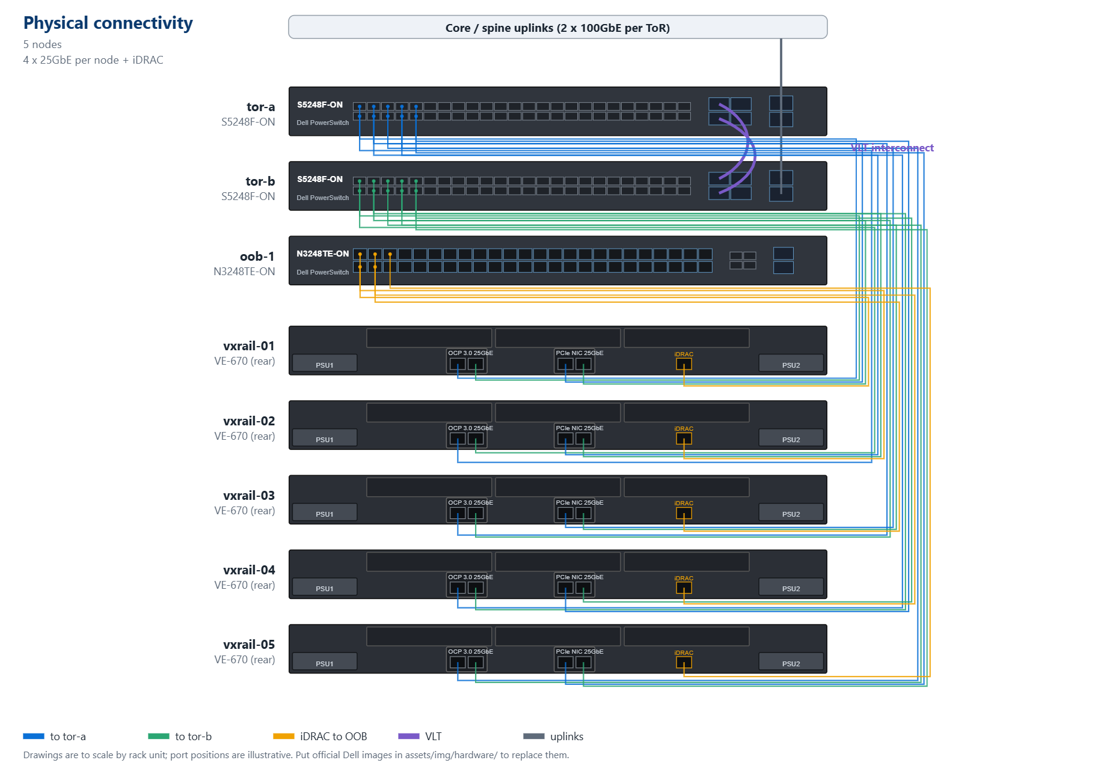
Figure 2 - Physical connectivity

Port map
Node | Port | NIC | Switch | Switch port | Speed
vxrail-01 | vmnic0 | OCP port 1 | tor-a | ethernet1/1/1 | 25GbE
vxrail-01 | vmnic1 | OCP port 2 | tor-b | ethernet1/1/1 | 25GbE
vxrail-01 | vmnic2 | PCIe port 1 | tor-a | ethernet1/1/6 | 25GbE
vxrail-01 | vmnic3 | PCIe port 2 | tor-b | ethernet1/1/6 | 25GbE
vxrail-01 | iDRAC | iDRAC dedicated | oob-1 | Gi 1/0/1 | 1GbE
vxrail-02 | vmnic0 | OCP port 1 | tor-a | ethernet1/1/2 | 25GbE
vxrail-02 | vmnic1 | OCP port 2 | tor-b | ethernet1/1/2 | 25GbE
vxrail-02 | vmnic2 | PCIe port 1 | tor-a | ethernet1/1/7 | 25GbE
vxrail-02 | vmnic3 | PCIe port 2 | tor-b | ethernet1/1/7 | 25GbE
vxrail-02 | iDRAC | iDRAC dedicated | oob-1 | Gi 1/0/2 | 1GbE
vxrail-03 | vmnic0 | OCP port 1 | tor-a | ethernet1/1/3 | 25GbE
vxrail-03 | vmnic1 | OCP port 2 | tor-b | ethernet1/1/3 | 25GbE
vxrail-03 | vmnic2 | PCIe port 1 | tor-a | ethernet1/1/8 | 25GbE
vxrail-03 | vmnic3 | PCIe port 2 | tor-b | ethernet1/1/8 | 25GbE
vxrail-03 | iDRAC | iDRAC dedicated | oob-1 | Gi 1/0/3 | 1GbE
vxrail-04 | vmnic0 | OCP port 1 | tor-a | ethernet1/1/4 | 25GbE
vxrail-04 | vmnic1 | OCP port 2 | tor-b | ethernet1/1/4 | 25GbE
vxrail-04 | vmnic2 | PCIe port 1 | tor-a | ethernet1/1/9 | 25GbE
vxrail-04 | vmnic3 | PCIe port 2 | tor-b | ethernet1/1/9 | 25GbE
vxrail-04 | iDRAC | iDRAC dedicated | oob-1 | Gi 1/0/4 | 1GbE
vxrail-05 | vmnic0 | OCP port 1 | tor-a | ethernet1/1/5 | 25GbE
vxrail-05 | vmnic1 | OCP port 2 | tor-b | ethernet1/1/5 | 25GbE
vxrail-05 | vmnic2 | PCIe port 1 | tor-a | ethernet1/1/10 | 25GbE
vxrail-05 | vmnic3 | PCIe port 2 | tor-b | ethernet1/1/10 | 25GbE
vxrail-05 | iDRAC | iDRAC dedicated | oob-1 | Gi 1/0/5 | 1GbE

9. Rules applied and sources
Type | Rule | Source | URL
Rule | vCenter Server appliance small: 4 vCPU, 21 GB RAM, 734 GB storage is included in the cluster demand. | vCenter Server Appliance Hardware Requirements | https://techdocs.broadcom.com/us/en/vmware-cis/vsphere/vsphere/8-0/vcenter-installation-and-setup/deploying-the-vcenter-server-appliance/vcenter-server-appliance-requirements/vcenter-server-appliance-hardware-requirements.html
Rule | VxRail Manager VM: 6 vCPU and 16 GB RAM reserved. | Dell KB 000223349 - VxRail Manager VM resources | https://www.dell.com/support/kbdoc/en-us/000223349/dell-vxrail-7-0-or-8-0-upgrade-error-error-while-extracting-the-composite-bundle-file
Rule | CPU demand = 542 vCPU ÷ 4:1 vCPU:pCore ratio = 135.6 physical cores (physical cores only, no hyper-threads). | vCPU to pCPU Ratio Guidelines | https://blogs.vmware.com/cloud-foundation/2025/06/04/vcpu-to-pcpu-ratio-guidelines/
Rule | 10% of host CPU reserved for vSAN; hosts sized to 80% maximum CPU utilisation. | VMware vSAN Design Guide (VCF 9.1) | https://www.vmware.com/docs/vmware-vsan-design-guide
Rule | CPU utilisation: 80% is a reasonable ceiling and 90% should be treated as a warning. | Performance Best Practices for vSphere/ESXi/vCenter 9.0 | https://www.vmware.com/docs/vsphere-esxi-vcenter-server-90-performance-best-practices
Rule | Memory: 10% per host reserved for ESXi/vSAN (planning assumption), 90% maximum utilisation, 1:1 memory overcommit. | Performance Best Practices for vSphere/ESXi/vCenter 9.0 | https://www.vmware.com/docs/vsphere-esxi-vcenter-server-90-performance-best-practices
Rule | HA: compute sized so the cluster runs all workloads with 1 host(s) failed (N+1). | vSphere HA Cluster Resources Percentage Admission Control | https://techdocs.broadcom.com/us/en/vmware-cis/vsphere/vsphere/8-0/vsphere-availability/creating-and-using-vsphere-ha-clusters/vsphere-ha-admission-control/cluster-resources-percentage-admission-control.html
Rule | vSAN ESA nodes require at least 16 CPU cores and 128 GB memory. | Designing and Sizing vSAN Hosts (VCF 9.0) | https://techdocs.broadcom.com/us/en/vmware-cis/vcf/vcf-9-0-and-later/9-0/vsan-deployment-administration-and-monitoring/vsan-planning-and-deployment/designing-and-sizing-a-virtual-san-cluster/designing-and-sizing-virtual-san-hosts.html
Rule | Operations reserve + host rebuild reserve applied for standard clusters with 4+ nodes; slack space otherwise. | KB 326889 - vSAN capacity utilisation / operations reserve | https://knowledge.broadcom.com/external/article/326889/vsan-health-service-capacity-utilizatio.html
Rule | At least one more host than the storage-policy minimum, so vSAN can rebuild after a host failure. | Adaptive RAID-5 Erasure Coding with vSAN ESA | https://blogs.vmware.com/cloud-foundation/2022/09/08/adaptive-raid-5-erasure-coding-with-the-express-storage-architecture-in-vsan-8/
Rule | Data reduction assumption 1.5:1 (keep conservative). | vSAN Space Efficiency Technologies (VCF 9.1) | https://www.vmware.com/docs/vmw-vsan-space-efficiency
Rule | VCF: per-core subscription, minimum 16 cores per CPU; includes 1 TiB of vSAN raw capacity per licensed core. | KB 313548 - Counting cores for VCF and VVF, vSAN capacity | https://knowledge.broadcom.com/external/article/313548/counting-cores-for-vmware-cloud-foundati.html

References
Organisation | Document | URL
VMware by Broadcom | VMware vSAN Design Guide (VCF 9.1) | https://www.vmware.com/docs/vmware-vsan-design-guide
VMware by Broadcom | vSAN Space Efficiency Technologies (VCF 9.1) | https://www.vmware.com/docs/vmw-vsan-space-efficiency
VMware by Broadcom | vSAN Stretched Cluster Guide | https://www.vmware.com/docs/vsan-stretched-cluster-guide
VMware by Broadcom | vSAN 2-Node Cluster Guide | https://www.vmware.com/docs/vmw-vsan-2-node-cluster-guide
VMware by Broadcom | Performance Best Practices for vSphere/ESXi/vCenter 9.0 | https://www.vmware.com/docs/vsphere-esxi-vcenter-server-90-performance-best-practices
Broadcom TechDocs | Using RAID 5 or RAID 6 Erasure Coding (vSAN 8) | https://techdocs.broadcom.com/us/en/vmware-cis/vsan/vsan/8-0/vsan-administration/increasing-space-efficiency-in-a-vsan-cluster/using-raid-5-6-erasure-coding-in-vsan-cluster.html
Broadcom TechDocs | About vSAN Policies | https://techdocs.broadcom.com/us/en/vmware-cis/vsan/vsan/8-0/vsan-administration/using-vsan-policies/about-vsan-policies.html
Broadcom TechDocs | Planning Capacity in vSAN | https://techdocs.broadcom.com/us/en/vmware-cis/vsan/vsan/8-0/planning-and-deployment/designing-and-sizing-a-virtual-san-cluster/sizing-a-virtual-san-datastore/planning-capacity-in-virtual-san.html
Broadcom TechDocs | About Reserved Capacity in vSAN Cluster | https://techdocs.broadcom.com/us/en/vmware-cis/vsan/vsan/8-0/vsan-monitoring/monitor-the-vsan-cluster/about-reserved-capacity-in-vsan-cluster.html
Broadcom TechDocs | Designing and Sizing vSAN Hosts (VCF 9.0) | https://techdocs.broadcom.com/us/en/vmware-cis/vcf/vcf-9-0-and-later/9-0/vsan-deployment-administration-and-monitoring/vsan-planning-and-deployment/designing-and-sizing-a-virtual-san-cluster/designing-and-sizing-virtual-san-hosts.html
VMware Blogs | Adaptive RAID-5 Erasure Coding with vSAN ESA | https://blogs.vmware.com/cloud-foundation/2022/09/08/adaptive-raid-5-erasure-coding-with-the-express-storage-architecture-in-vsan-8/
VMware Blogs | Auto-RAID in vSAN for VCF 9.1 | https://blogs.vmware.com/cloud-foundation/2026/05/08/auto-raid-in-vsan-for-vcf-9-1/
VMware Blogs | Understanding Reserved Capacity Concepts in vSAN | https://blogs.vmware.com/cloud-foundation/2022/02/18/understanding-reserved-capacity-concepts-in-vsan/
VMware Blogs | Lower hardware requirements for vSAN (ReadyNode profiles) | https://blogs.vmware.com/cloud-foundation/2025/11/14/driving-down-storage-costs-with-lower-hardware-requirements-for-vsan/
VMware Blogs | vCPU to pCPU Ratio Guidelines | https://blogs.vmware.com/cloud-foundation/2025/06/04/vcpu-to-pcpu-ratio-guidelines/
VMware Blogs | vSAN Networking - Teaming for Performance | https://blogs.vmware.com/cloud-foundation/2025/05/27/vsan-networking-teaming-for-performance/
Broadcom Knowledge Base | KB 326889 - vSAN capacity utilisation / operations reserve | https://knowledge.broadcom.com/external/article/326889/vsan-health-service-capacity-utilizatio.html
Broadcom Knowledge Base | KB 372311 - When 10Gb is used for the vSAN ESA network | https://knowledge.broadcom.com/external/article/372311/when-10gb-is-used-for-the-vsan-esa-netwo.html
Broadcom TechDocs | vSphere HA Cluster Resources Percentage Admission Control | https://techdocs.broadcom.com/us/en/vmware-cis/vsphere/vsphere/8-0/vsphere-availability/creating-and-using-vsphere-ha-clusters/vsphere-ha-admission-control/cluster-resources-percentage-admission-control.html
Broadcom TechDocs | vCenter Server Appliance Hardware Requirements | https://techdocs.broadcom.com/us/en/vmware-cis/vsphere/vsphere/8-0/vcenter-installation-and-setup/deploying-the-vcenter-server-appliance/vcenter-server-appliance-requirements/vcenter-server-appliance-hardware-requirements.html
Dell Technologies | Dell KB 000223349 - VxRail Manager VM resources | https://www.dell.com/support/kbdoc/en-us/000223349/dell-vxrail-7-0-or-8-0-upgrade-error-error-while-extracting-the-composite-bundle-file
Broadcom TechDocs | Deploying a vSAN Witness Appliance (VCF 9.0) | https://techdocs.broadcom.com/us/en/vmware-cis/vcf/vcf-9-0-and-later/9-0/vsan-deployment-administration-and-monitoring/vsan-planning-and-deployment/working-with-virtual-san-stretched-cluster/deploying-a-witness-appliance.html
Broadcom Knowledge Base | KB 313548 - Counting cores for VCF and VVF, vSAN capacity | https://knowledge.broadcom.com/external/article/313548/counting-cores-for-vmware-cloud-foundati.html
Broadcom | VMware Cloud Foundation Specific Program Documentation (Feb 2026) | https://ftpdocs.broadcom.com/cadocs/0/VCF_SPD_February2026.pdf
Broadcom | VMware vSphere Foundation Specific Program Documentation (Feb 2026) | https://ftpdocs.broadcom.com/cadocs/0/VVF_SPD_February2026.pdf
Dell Technologies | Dell KB 000310965 - VxRail licensing when upgrading 8.0 to 9.0 | https://www.dell.com/support/kbdoc/en-us/000310965/vxrail-licensing-implication-when-upgrading-from-vxrail-8-0-x-to-9-0-x
Dell Technologies | Dell VxRail Spec Sheet (H16763) | https://www.delltechnologies.com/asset/en-us/products/converged-infrastructure/technical-support/h16763-vxrail-spec-sheet.pdf
Dell Technologies | Dell VxRail HCI (dell.com) | https://www.dell.com/en-us/shop/storage-servers-and-networking-for-business/sf/vxrail-hci
Dell Technologies | Dell KB 000023374 - VxRail models to PowerEdge models | https://www.dell.com/support/kbdoc/en-us/000023374/vxrail-models-to-dell-poweredge-models
Dell Technologies | VxRail VE-660 Hardware Requirements and Specifications | https://www.dell.com/support/manuals/en-us/vxrail-appliance-series/vxr_p_ve-660/overview?guid=guid-f35a4f96-8dd3-447d-9aa5-bde09875b5e0&lang=en-us
Dell Technologies | VxRail VP-760 / VS-760 Hardware Requirements and Specifications | https://www.dell.com/support/manuals/en-ae/vxrail-vs-760/vxr_p_vp-760/processor-specifications?guid=guid-475bbeee-90e2-49d3-9ea8-77b944618d37&lang=en-us
Dell Technologies | VxRail VE-6615 Hardware Requirements and Specifications | https://www.dell.com/support/manuals/en-us/vxrail-appliance-series/vxr_p_ve-6615/processor-specifications?guid=guid-1f4a24cc-aae7-45c1-bd31-98b68ad6e806&lang=en-us
Dell Technologies | VxRail VP-7625 Hardware Requirements and Specifications | https://www.dell.com/support/manuals/en-us/vxrail-appliance-series/vxr_p_vp-7625/system-overview?guid=guid-843048af-d602-4ea7-9cfa-0da6f0dcd8c7&lang=en-us
Dell Technologies | VxRail VD-4000r Configurations and Features | https://www.dell.com/support/manuals/en-us/vxrail-appliance-series/vxr_p_vd-4000r/configurations-and-features?guid=guid-a0d09007-5051-4f88-960e-1224dc2786d5&lang=en-us
Dell Technologies | Dell VxRail Network Planning Guide (H15300.37, June 2026) | https://www.dell.com/support/manuals/en-us/vxrail-appliance-series/vxrail_planning_guide
Dell Technologies | Network Planning Guide - VLAN considerations | https://www.dell.com/support/manuals/en-us/vxrail-appliance-series/vxrail_planning_guide/vlan-considerations-for-vxrail-networks?guid=guid-9439187f-e0ea-4b10-9d0b-ec159023206e&lang=en-us
Dell Technologies | Network Planning Guide - VxRail networking port options | https://www.dell.com/support/manuals/en-us/vxrail-appliance-series/vxrail_planning_guide/vxrail-networking-port-options?guid=guid-6cd21b35-fb08-473f-a287-783b3aed4df9&lang=en-us
Dell Technologies | Network Planning Guide - Switch considerations | https://www.dell.com/support/manuals/en-us/vxrail-appliance-series/vxrail_planning_guide/switch-considerations?guid=guid-d04ee3b1-6c91-4fd8-b4d3-52a52102c471&lang=en-us
Dell Technologies | Network Planning Guide - Teaming and failover policies | https://www.dell.com/support/manuals/en-us/vxrail-appliance-series/vxrail_planning_guide/teaming-and-failover-policies-for-vxrail-networks?guid=guid-c7125253-3003-45cd-8b52-9999f02e01e6&lang=en-us
Dell Technologies | Network Planning Guide - Data center network MTU | https://www.dell.com/support/manuals/en-us/vxrail-appliance-series/vxrail_planning_guide/prepare-data-center-network-mtu?guid=guid-4d3e55b8-135f-4ef7-81a6-0301d139c204&lang=en-us
Dell Technologies | Network Planning Guide - Node discovery and the Ethernet switch | https://www.dell.com/support/manuals/en-us/vxrail-appliance-series/vxrail_planning_guide/vxrail-node-discovery-and-the-ethernet-switch?guid=guid-41425c8d-482d-4c8a-b7f4-cd1a9c717286&lang=en-us
Dell Technologies | Network Planning Guide - 2-node cluster | https://www.dell.com/support/manuals/en-us/vxrail-appliance-series/vxrail_planning_guide/2-node-cluster?guid=guid-519032f2-5b7e-43de-a822-823b4fb9b591&lang=en-us
Dell Technologies | Network Planning Guide - Flow control | https://www.dell.com/support/manuals/en-us/vxrail-appliance-series/vxrail_planning_guide/enable-flow-control?guid=guid-dc6a78f5-a34a-4549-b59e-b39ac27ef785&lang=en-us
Dell Technologies | VxRail Architecture Overview - vSAN ESA | https://www.dell.com/support/manuals/en-us/vxrail-appliance-series/vxrail_architecture_guide/vmware-vsan-esa-overview?guid=guid-8d1e6123-bbd1-425c-af5b-b089eabe8c25&lang=en-us
Dell Technologies | VxRail 8.0.x Administration Guide - Expand a cluster | https://www.dell.com/support/manuals/en-us/vxrail-appliance-series/vxrail-8.x_admin_guide/expand-a-cluster?guid=guid-6f3b67ad-1445-4e6d-af86-7fdcd9a4f3de&lang=en-us
Dell Technologies | Dell KB 000203918 - Witness networking requirements | https://www.dell.com/support/kbdoc/en-us/000203918/vxrail-networking-requirements-for-a-vsan-witness-appliance-for-a-stretched-or-2-node-cluster
Dell Technologies | Dell PowerSwitch S5200-ON Series Spec Sheet | https://www.delltechnologies.com/asset/en-us/products/networking/technical-support/dell_emc_networking-s5200_on_spec_sheet.pdf
Dell Technologies | Dell PowerSwitch S5448F-ON Spec Sheet | https://www.delltechnologies.com/asset/en-us/products/networking/technical-support/dell-emc-powerswitch-s5448f-on-spec-sheet.pdf
Dell Technologies | Dell PowerSwitch S4100-ON Series Spec Sheet | https://www.delltechnologies.com/asset/en-us/products/networking/technical-support/dell-networking-s4100-series-spec-sheet.pdf
Dell Technologies | Dell PowerSwitch Z9432F-ON Spec Sheet | https://www.delltechnologies.com/asset/en-us/products/networking/technical-support/dell-emc-powerswitch-z9432f-spec-sheet.pdf
Dell Technologies | Dell PowerSwitch Z9264F-ON Installation Guide | https://www.dell.com/support/manuals/en-us/networking-z9264f-on/z9264f-on_install_pub/introduction?guid=guid-641d4c2c-fce8-4960-8706-cd44603c7b26&lang=en-us
Dell Technologies | Dell PowerSwitch N3200-ON Series Spec Sheet | https://www.delltechnologies.com/asset/en-gb/products/networking/technical-support/dell-networking-n3200-powerswitch-specsheet.pdf
Dell Technologies | Dell PowerSwitch S3248T-ON Spec Sheet | https://www.delltechnologies.com/asset/en-us/products/networking/technical-support/dell-powerswitch-s3248t-on-spec-sheet.pdf

VxRail Sizer is a planning aid and is not a Dell Technologies or Broadcom product.

