Niyaasoft

WAF sizing and design
Public portal WAF refresh
Customer | Niyyasoft
Site / environment | Riyadh DC
Recommended platform | NetScaler MPX 8930 (Premium)
Deployment | 2 x 1U Rack, reverse proxy (full proxy)
Prepared by | Niyyasoft
Date | 20 September 2026

Executive summary
For Niyyasoft at Riyadh DC we recommend 2 units of the NetScaler MPX 8930 (Premium), running NetScaler Web App Firewall (AppFirewall) - Premium edition, deployed as an active/standby pair in reverse proxy (full proxy). Once the inspection options, growth and design headroom are applied, each unit has to carry 89K/s, 17.9 Gbps and 8K/s of new TLS handshakes. The NetScaler MPX 8930 (Premium) is rated at 420K/s and 24 Gbps, which puts it at approximately 74% of its capacity at the end of the term, with throughput as the limiting dimension.

Points the reviewer should see
- The Web App Firewall needs NetScaler Premium edition. A Standard or Advanced licence cannot run AppFirewall at any platform size, so an existing estate on those editions needs an edition upgrade as well as capacity.

1. Requirements
The figures below are the inputs to the sizing. Anything marked as not measured was derived, and the assumption used is named in section 5.
Customer | Niyyasoft
Site / environment | Riyadh DC
Application profile | E-commerce / public website
Protected applications | 5 across 1 site
Where the WAF sits | Internet edge / public web apps
Insertion mode | Reverse proxy (full proxy)
Measured peak request rate | 24K/s
Measured peak throughput | 3.2 Gbps
Concurrent users | 45,000
Average transaction size | 25 KB
Encrypted traffic | 100% over TLS, RSA 2048 keys
Requests per TLS connection | 8
Re-encrypt to back end | No - clear text to the server pool
Security capabilities | Bot management and scraping defence; Application-layer (L7) DoS protection
High availability | Active / standby pair (2 units)
Growth allowance | 20% a year for 3 years
Design headroom | 35% spare at end of term
Form factor | Any (no preference)
Compliance driver | Not specified

2. How the size was calculated
NetScaler sizes on system throughput, HTTP requests per second, SSL bulk throughput and SSL transactions per second at RSA-2048 or ECDSA P-256. AppFirewall runs in the packet-processing path, so the figure that matters is throughput and request rate with the firewall profile applied - typically a third of the system rating once signatures, learning and bot protection are on. Each step below is applied in order, and the result is the rating every candidate platform is measured against.
Step | Result | How it was reached
Day-one request rate | 24K/s | The highest of every figure the form could produce, because a WAF has to survive the worst of them: 24K/s entered as the measured peak; 45,000 users x 0.5 req/s each = 23K/s; 3.2 Gbps at 25 KB per transaction = 16K/s.
Day-one application throughput | 4.8 Gbps | 24K/s x 25 KB x 8 bits = 4.8 Gbps.
New TLS handshakes per second | 3K/s (RSA 2048) | 24K/s / 8 requests per connection x 100% encrypted. This is the figure that sinks most WAF designs: handshake capacity runs out long before throughput does.
Inspection cost factor | x1.40 | Base signature and protocol policy, plus: Bot management and scraping defence +25%, Application-layer (L7) DoS protection +15%. Vendor ratings are published with a standard policy, so a heavier policy has to be paid for in platform size.
Insertion mode factor | x1.00 | Reverse proxy (full proxy). The WAF terminates the client connection and opens its own to the server. Full request and response inspection, TLS termination, header rewriting and response blocking. The default for all three vendors.
Growth to end of term | x1.73 | 20% a year compounded over 3 years. The platform is sized for the last year of its life, not the first.
Design headroom | 35% spare (divide by 0.65) | The platform is sized to run at no more than 65% of its rating at the end of the term, leaving room for an attack, a failover and a policy that grows.
Load carried by each unit | 100% of total, across 2 units | Active / standby pair. The standby unit carries the full load the moment the active one fails, so both are sized identically for 100%.
Concurrent connections | 479K | 180,000 entered, then grown and de-rated like everything else.
Required per-unit rating | 89K/s / 17.9 Gbps / 8K/s TLS | Day-one figures x 1.40 inspection x 1.00 mode x 1.73 growth / 0.65 headroom x 1.00 HA share. Every model below is measured against these four numbers.

3. The recommended platform
One box does load balancing, GSLB, TLS offload, caching, compression, bot management and the WAF, with a single licence edition covering the lot. Pooled capacity means throughput can be moved between appliances and form factors as the estate changes, which no other vendor here matches as cleanly.
Worth knowing: The WAF needs Premium edition. Standard and Advanced licences will not run AppFirewall, so an upgrade to Premium is part of the sizing answer whenever an existing Standard or Advanced estate is being extended. VPX throughput is licensed, not physical - a VPX 3000 will not pass more than 3 Gbps whatever the host can do.
Vendor | Citrix NetScaler - NetScaler Web App Firewall (AppFirewall) - Premium edition
Model | NetScaler MPX 8930 (Premium)
Product family | MPX 8900
Form factor | 1U Rack (x2)
WAF request rate | 420K/s
WAF throughput | 24 Gbps
L7 throughput without WAF | 55 Gbps
TLS handshakes/sec | 28K/s RSA 2048, 72K/s ECDSA P-256 (sized on RSA)
Bulk TLS throughput | 26 Gbps
Concurrent connections | 24M
Rated applications | 80
Interfaces | 8x 10GbE SFP+, 4x 25GbE SFP28
High availability | Active/Passive, Cluster
Operating system | NetScaler (Citrix ADC) firmware
Management | NetScaler Console (formerly Citrix ADM), on-premises or cloud
Positioning | Top of the MPX 8900 range.

4. Inspection design
These are the stages a request passes through, in order, with the options this design enables. Each stage costs processing capacity, which is why the inspection factor in section 2 is what it is.
# | Stage | What it does
1 | Accept and TCP/TLS terminate | 100% TLS, RSA 2048
2 | L7 DoS defence | Behavioural rate and pattern control
3 | Bot management | Fingerprint, challenge, rate limit
4 | Protocol compliance | RFC checks, method and length limits
5 | Signatures and policy | Injection, XSS, traversal, CVE rules
6 | Forward to server pool | Single pool, no load balancing

A request that violates the policy is blocked before it reaches the application, a support ID (not the reason) is returned to the client, and the full transaction is logged for the audit trail.

5. Licensing and bill of materials
Every line below is here because of something in section 1. This is the shape of the order, not a quotation: term, support tier and discount all change the commercial outcome.
Item | Type | Qty | Why it is on the list
NetScaler MPX 8930 (Premium) | Platform | 2 | Active / standby pair, each unit sized for 100% of the load.
NetScaler Premium edition | Module | 2 | Mandatory on every deployment of this platform.
Platform licence (MPX / SDX / VPX / BLX / CPX) | Module | 2 | Mandatory on every deployment of this platform.
Bot Management | Module | 2 | Asked for: Bot management and scraping defence.
WAF signature and security updates | Subscription | 1 | Required to keep the negative security model current.
NetScaler support (Select / Premier) | Support | 2 | Mandatory on every deployment of this platform.

6. How the three vendors compare
The same requirement measured against each vendor range. The smallest qualifying model is shown for each, so the comparison is like for like rather than a comparison of flagship platforms.
Vendor | Smallest model that fits | Form | Requests/s | Throughput | TLS/s | Fit | Load | Limited by
F5 | No qualifying model | - | - | - | - | - | - | -
Imperva | No qualifying model | - | - | - | - | - | - | -
Citrix NetScaler (selected) | NetScaler MPX 8930 (Premium) | 1U Rack | 420K/s | 24 Gbps | 28K/s | 100% | 74% | throughput

Fit is the weakest dimension measured against the requirement, not an average: a platform that covers the throughput twice over but only 40% of the TLS handshake rate does not fit 70%, it fails. 100% means every dimension is met; the Load column then says how much of that capacity the design actually uses.

8. Diagrams

Connectivity design
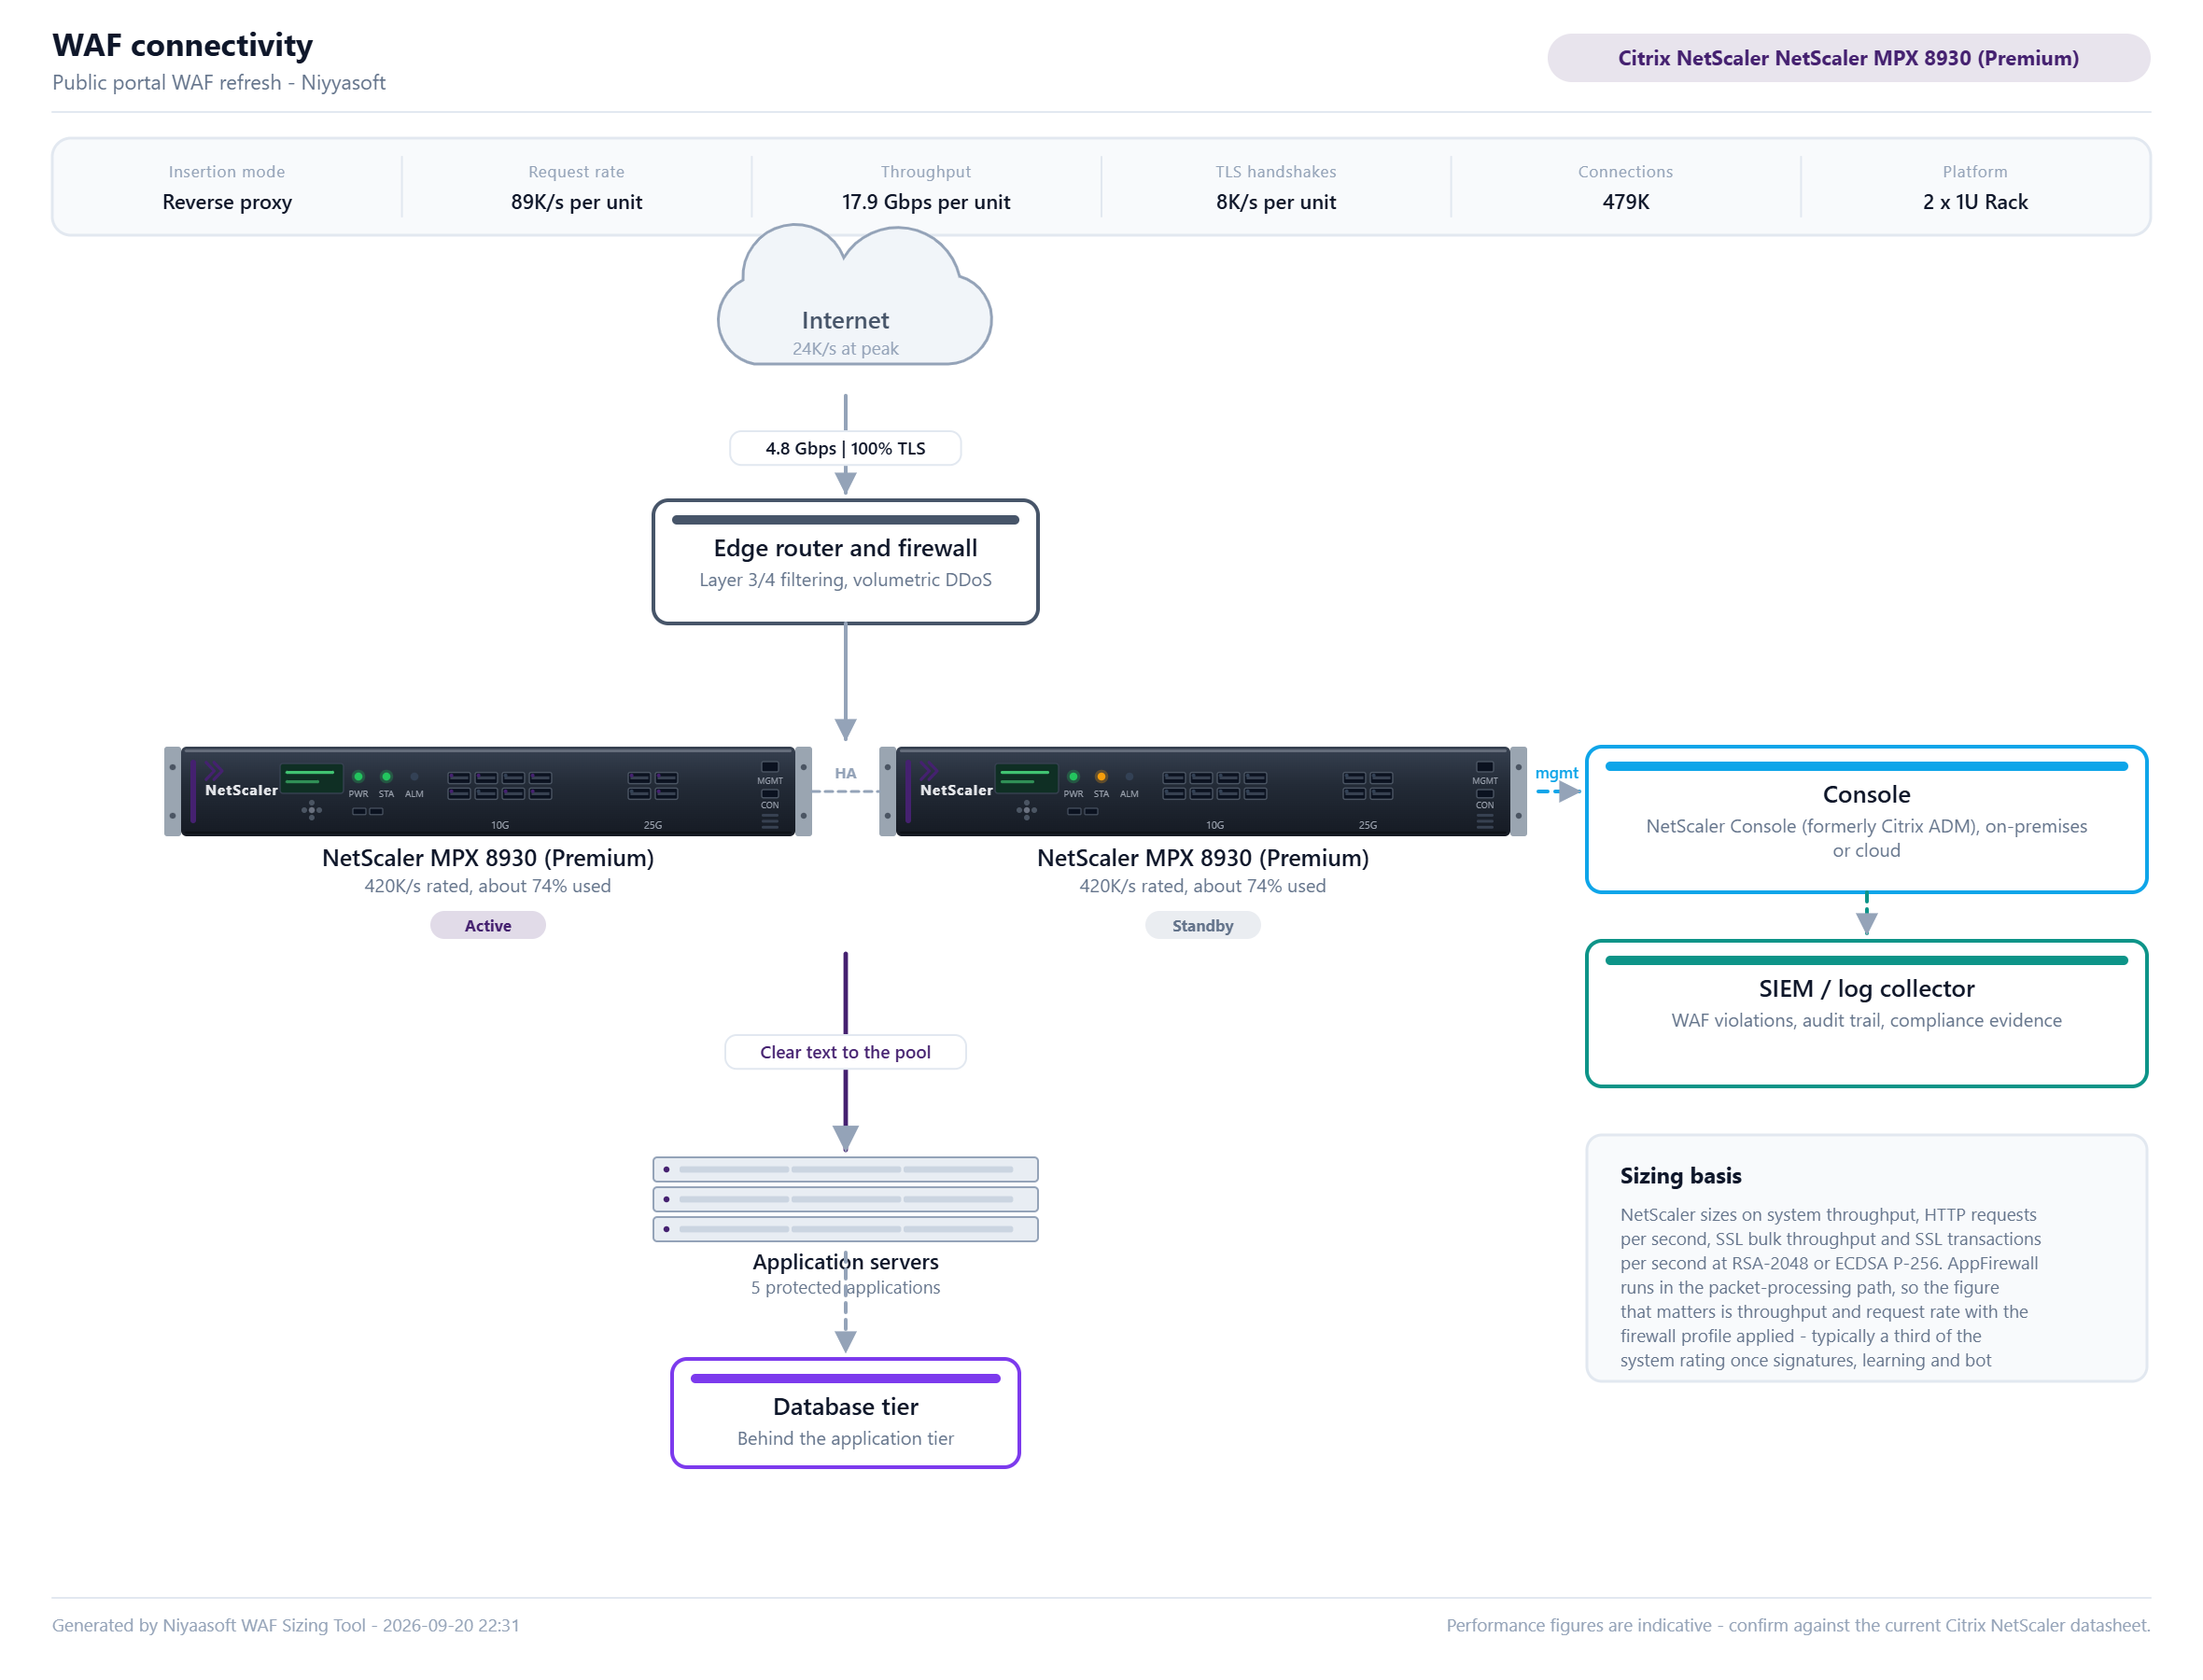
How the WAF is inserted into the traffic path, drawn with the port layout of the chosen platform.

Inspection design
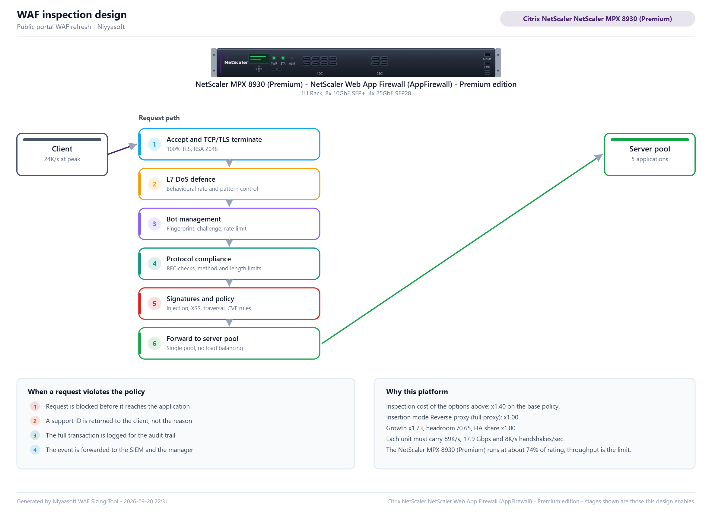
What the WAF does to a request between accepting it and passing it to the application.

9. Assumptions and caveats
- Performance figures in this document are indicative values held for relative sizing between models. Each vendor publishes against a different test profile and revises the numbers per software release, so the final model must be confirmed against the current Citrix NetScaler datasheet before a quotation is issued.
- The sizing is driven by layer-7 request rate, application throughput, new TLS handshake rate and concurrent connections. A WAF is not sized on the headline throughput of the platform: with a production policy enabled the usable rate is a fraction of it.
- Growth of 20% a year has been compounded over 3 years, and the platform is sized to run at no more than 65% of its rating at the end of that term.
- Each unit in the high-availability group is sized to carry 100% of the total load, so the loss of one unit does not degrade the service. Sizing a pair at half the load each is the most common WAF sizing error and is deliberately not done here.
- TLS handshake capacity has been sized on RSA-2048 certificates. Moving to ECDSA P-256 would roughly double the available handshake rate on the same platform, which is often cheaper than moving up a model.
- Licensing shown is the bill of materials the design implies, not a quotation. Term length, support tier, discount level and any existing entitlement all change the commercial outcome and must be confirmed with the vendor or distributor.
Generated by Niyaasoft WAF Sizing Tool - generated 2026-09-20 22:31

